**INTEREST LOAN PROJECT DOCUMENTATION**

project summary

* The **Interest Loan Application** is comprehensive financial management software designed to streamline and automate loan-related operations. Developed using PHP, JavaScript, Bootstrap, and jQuery, the application offers a responsive and user-friendly interface tailored for financial institutions such as banks, credit unions, and microfinance organizations.
* The primary objective of the application is to provide an end-to-end solution for managing loans — from entry and approval to disbursement, collection, and closure. By automating these processes, the software minimizes manual effort, reduces errors, and enhances data accuracy and operational efficiency.
* In conclusion, the **Interest Loan Application** serves as a powerful tool for financial organizations seeking to improve their loan management capabilities. With its intuitive interface, robust feature set, and strong security framework, it significantly enhances service delivery and operational performance.

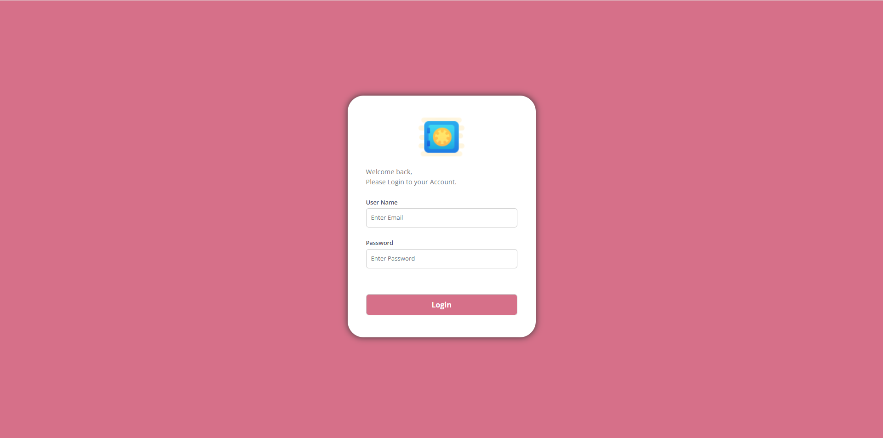

TECHNICAL SPECIFICATION

• CORE PHP

• HTML, CSS, BOOTSTRAP

• JAVASCRIPT, JQUERY

• MYSQL

SOFTWARE REQUIREMENTS

• XAMPP VERSION - 7.4

• PHP VERSION – 8.2

• BOOTSTRAP VERSION - 4

SYSTEM REQUIREMENTS

• OS – Windows 10 - 64 bit

• Processor Intel i5

• Ram 8GB

MODULES

• DASHBOARD

• MASTER

• ADMINISTRATION

• LOAN ENTRY

• APPROVAL

• LOAN ISSUE

• COLLECTION

• CLOSED

• NOC

• ACCOUNTS

• UPDATE

• CUSTOMER DATA

• SEARCH

• REPORTS

• BULK UPLOAD

**DASHBOARD SCREEN**

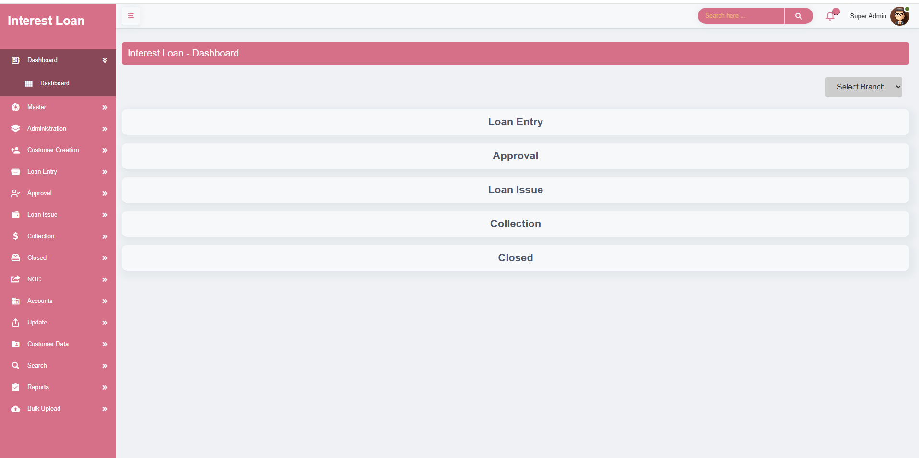

* The Dashboard serves as a centralized summary screen for tracking and managing the full loan lifecycle. It provides real-time insights into loan activity at every stage, helping users monitor progress, performance, and actions required.
* The Dashboard provides both **overall** and **branch-wise** visibility across the complete loan lifecycle. Admins and branch managers can track performance, operational flow, and financial metrics for each stage of loan processing, tailored to their specific branch.
* The section of the dashboard provides a visual summary of the loan repayment status, focusing on amounts paid, pending, and overdue (OD). This helps users monitor the effectiveness of collections and identify areas requiring attention.
* The Purpose and Benefits of Dashboard Enables quick assessment of collection performance. Helps identify if there are any overdue or pending payments requiring follow-up.

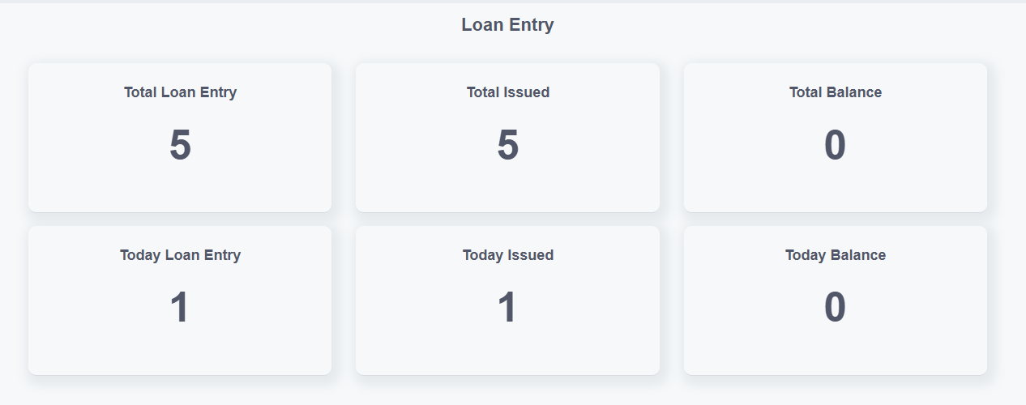

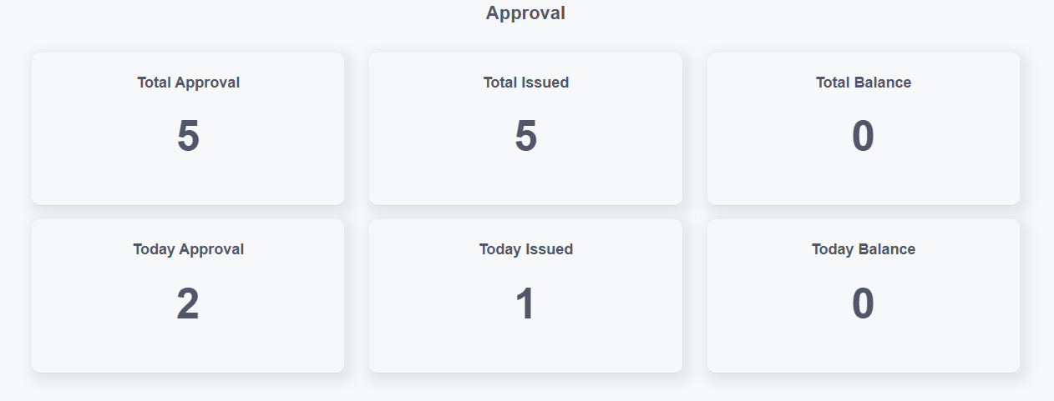

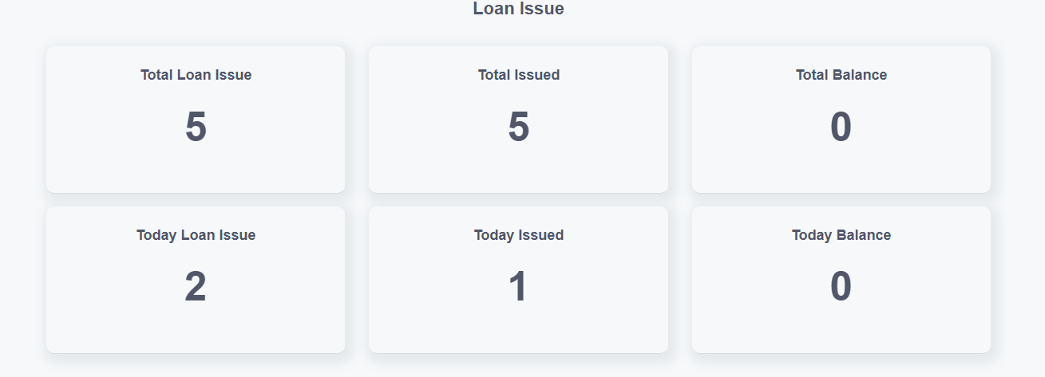

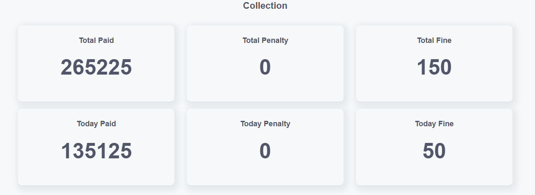

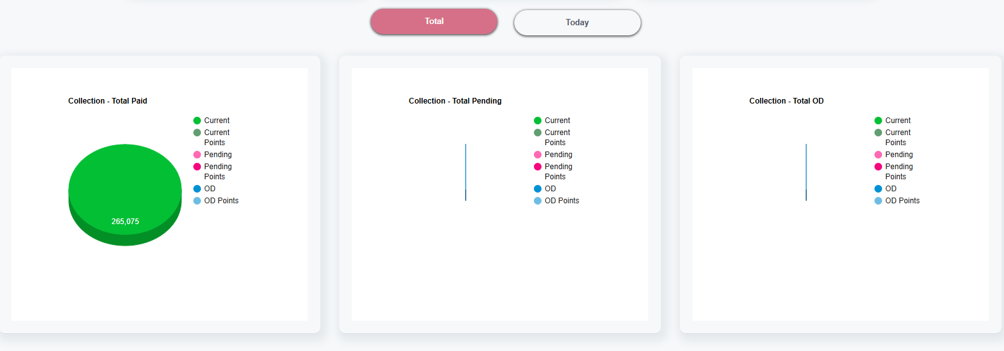

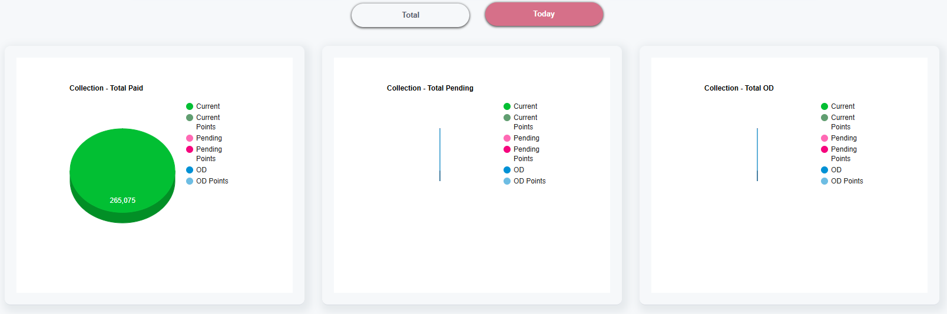

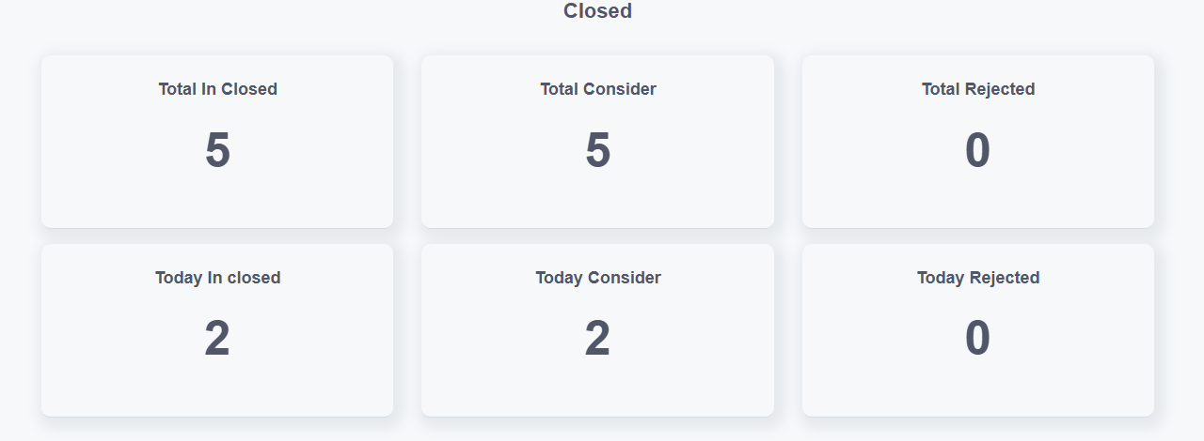

* The dashboard provides a centralized overview of all loan operations, including entries, approvals, issuances, collections, and closures. It displays both **total** and **today’s** statistics to help institutions monitor performance and take timely actions.

Key metrics include:

* **Total Entries, Approvals, Issued Loans, Collections, and Closed Loans** to track the cumulative volume of each stage.
* **Total Balances** at each stage to highlight pending actions — such as loans awaiting approval, disbursement, or collection.
* **Today's Activity** across all modules — including loans entered, approved, issued, collected, or closed — to give a snapshot of daily operations.
* **Today’s Balances** to indicate current-day pending tasks that require follow-up or completion.
* **Amount-Based Metrics** like issued amounts, collections, and closed amounts to provide financial visibility in real-time.
* This unified view ensures that financial institutions can efficiently monitor loan flow, identify bottlenecks, and maintain operational control with clear and actionable data at every step.

**MASTER – COMPANY CREATION**

* In this section, please provide the basic details about your company. **The following fields are mandatory**: company name, address, state, district, taluk, place, and pin code. These details are essential to help us accurately identify and map your business location.
* You’ll also have the option to add your communication details, such as website, email ID, mobile number, What Sapp number, and landline number. While these are optional, providing them ensures smoother communication and better support.
* The Company Creation screen is designed for single-company entry, ensuring that only one company profile can be created and managed through this interface. This limitation is intentional to maintain data integrity and prevent duplication within the system.
* Users can click the **Edit** button beside any company record. This will load the selected company details into the form for easy modification. After editing, clicking **Update** will save the changes.

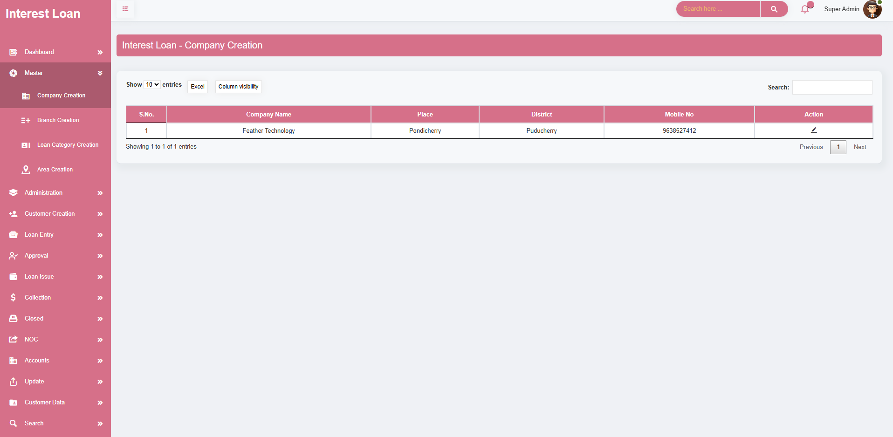

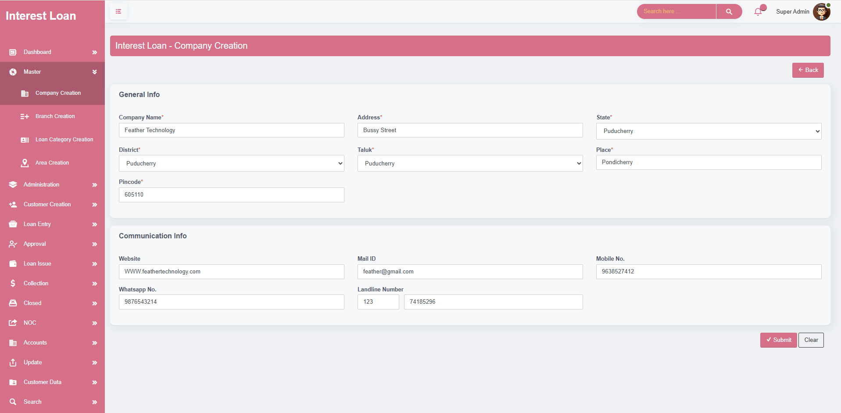

**MASTER – BRANCH CREATION**

* The **Branch Creation** module allows you to add and manage different branches under a company. It captures all essential branch information such as branch name, address, location, and contact details. This helps maintain a structured and well-organized company hierarchy.
* When a user enters the **Company Name**, the system automatically generates a **Branch Code**. The branch code is prefixed with the **first letter of the company name**, followed by a unique number. Example: If the company name is **Finance**, the generated branch code will be **F-101.** This ensures consistency, avoids duplicates, and simplifies branch identification
* Users can click the **Edit** button beside any branch record. This will load the selected branch details into the form for easy modification. After editing, clicking **Update** will save the changes.
* Each branch row includes a **Delete** button. Clicking this prompts a confirmation before permanently removing the branch from the system . Helps maintain clean and updated records

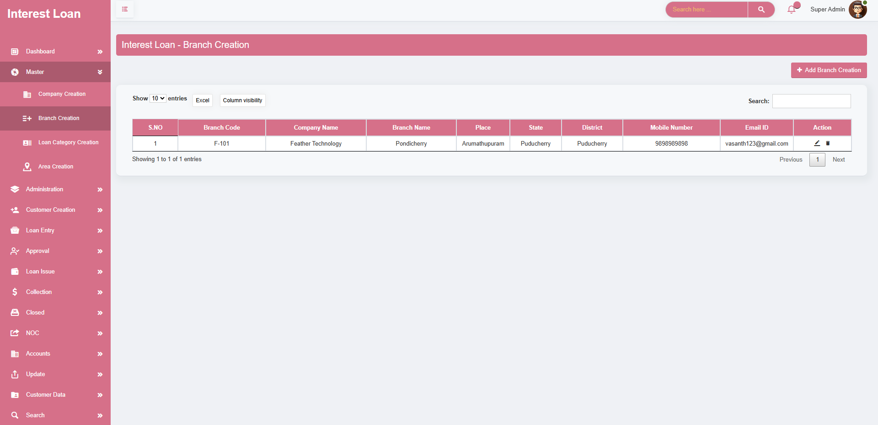

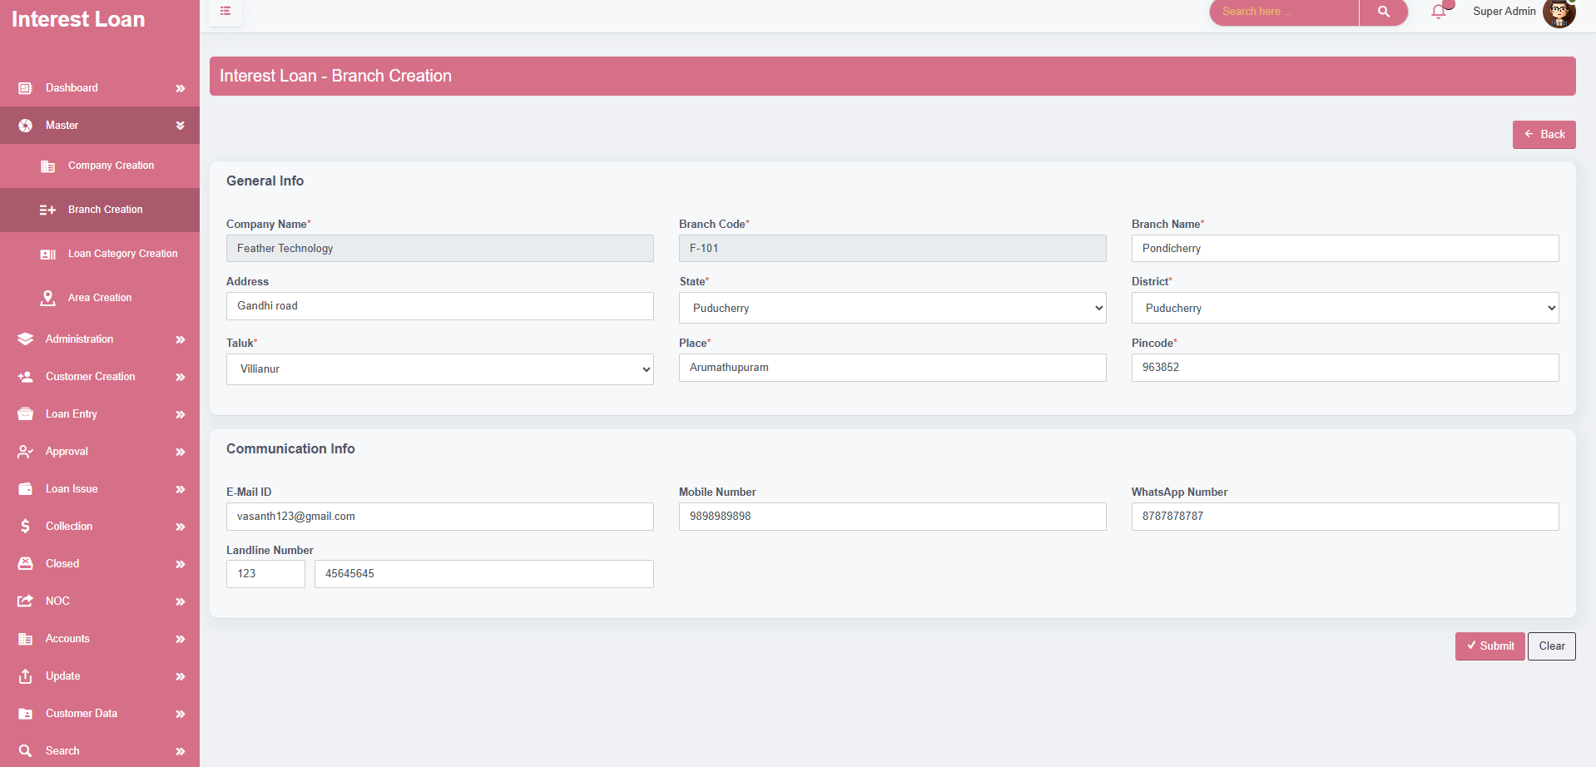

**MASTER – LOAN CATEGORY CREATION**

* The **Loan Category Creation** module allows you to define different types of loans based on business needs. It lets you configure key financial rules such as loan limits, interest structure, due methods, and applicable charges. This ensures consistency and control across all loan offerings
* Define the type of loan you are creating and set a maximum limit for the loan amount that can be issued under this category.
* Choose how profits or interest will be calculated for this loan category. You can configure whether it’s based on a flat rate, reducing balance, or any other method relevant to your organization.
* Set the due schedule for repayments, such as monthly or any other cycle, and define how dues are calculated—whether based on date or completion logic.
* Determine whether dues apply to just the interest, just the principal, or both, and configure when benefits (interest/profit) are applied—either before or after the benefit period.
* Specify the overall loan duration in months, helping to clearly define the repayment period for borrowers.
* Configure minimum and maximum interest rates to maintain flexibility while staying within acceptable lending standards.
* Set up document charges and processing fees either as percentages, fixed amounts, or both—ensuring you can adjust charges based on the loan size.
* Include rules for overdue penalties, so that any delayed repayments incur charges as per the organization’s policy. This helps encourage timely payments.
* **Edit and delete options** are provided for each loan category, allowing administrators to update existing loan configurations or remove outdated categories as needed, ensuring the system stays clean and accurate.

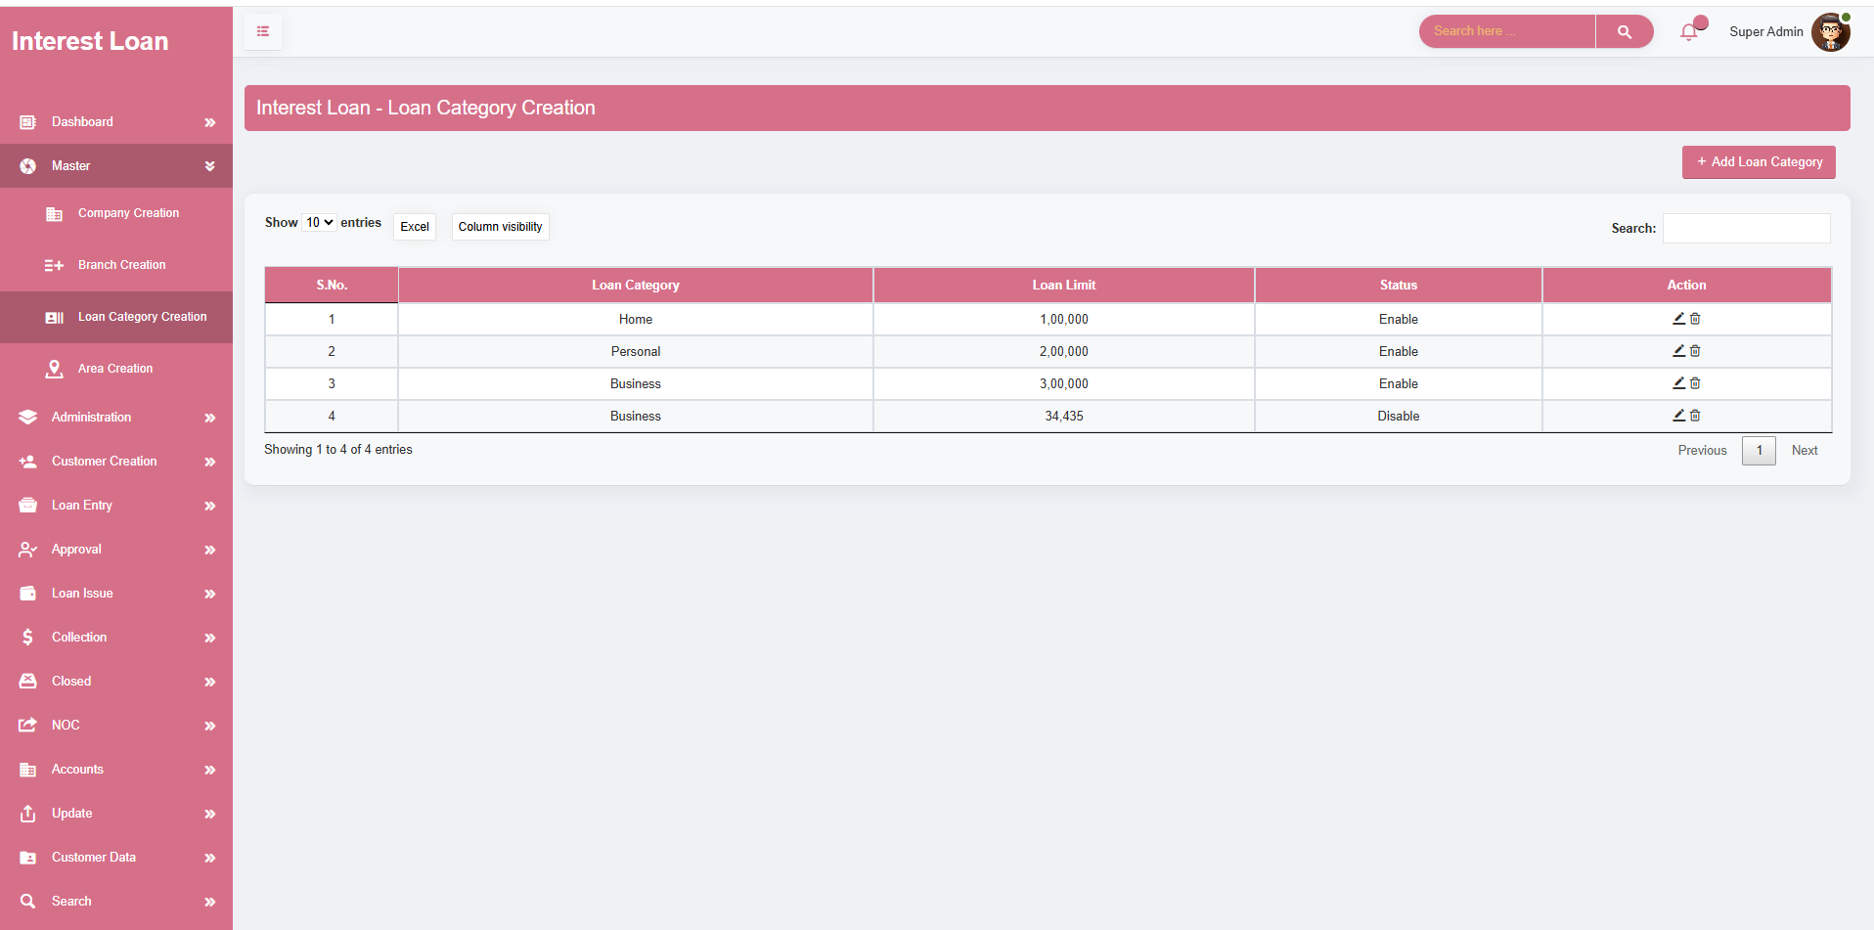

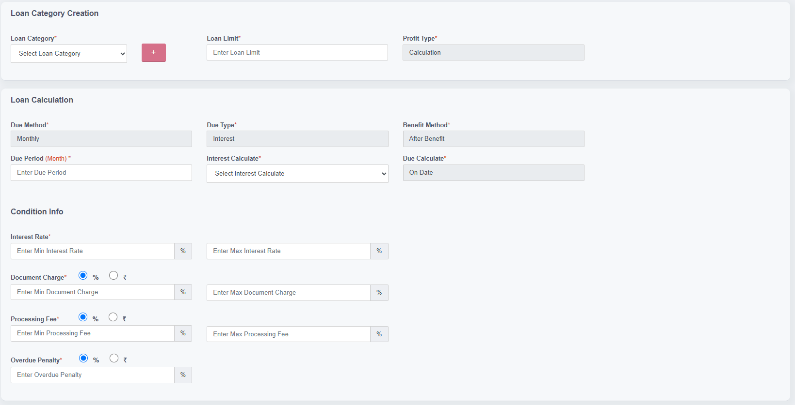

**MASTER – AREA CREATION**

* The **Area Creation** module is used to map areas under specific branches and lines. It ensures structured and non-redundant mapping of operational areas, helping the organization manage regions and allocations efficiently.
* To begin area creation, the user must first **select a branch**. This is a mandatory step, as lines and areas are mapped under specific branches.
* If the user attempts to proceed without selecting a branch, the system will **display an alert** message **“Kindly Select the Branch Name”**, preventing further action until a branch is chosen.
* Once a branch is selected, the system enables the selection of a **line name** and an **area name**, allowing the user to map areas under the correct hierarchy.
* After a line and area have been mapped to a branch, that specific combination **cannot be remapped or reused** again.
* If a new mapping is needed, the user must **create a new area or line** and map it under the appropriate branch to maintain data integrity and avoid duplicates.
* **Edit and delete options** are provided for each Area Creation, allowing to create new area creation.
* Allows administrators to create areas and assign multiple areas to branches, agents, or users for better operational management and tracking.
* Provides functionality to update existing area names and reassign them without disrupting existing customer or loan data linked to those areas.
* The Area Creation screen enables structured creation and management of geographical areas, ensuring organized customer allocation and smoother operational workflows.

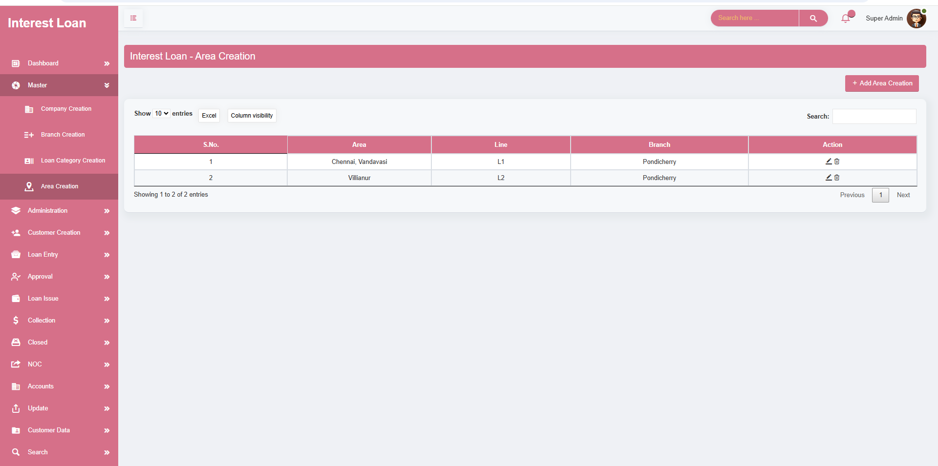

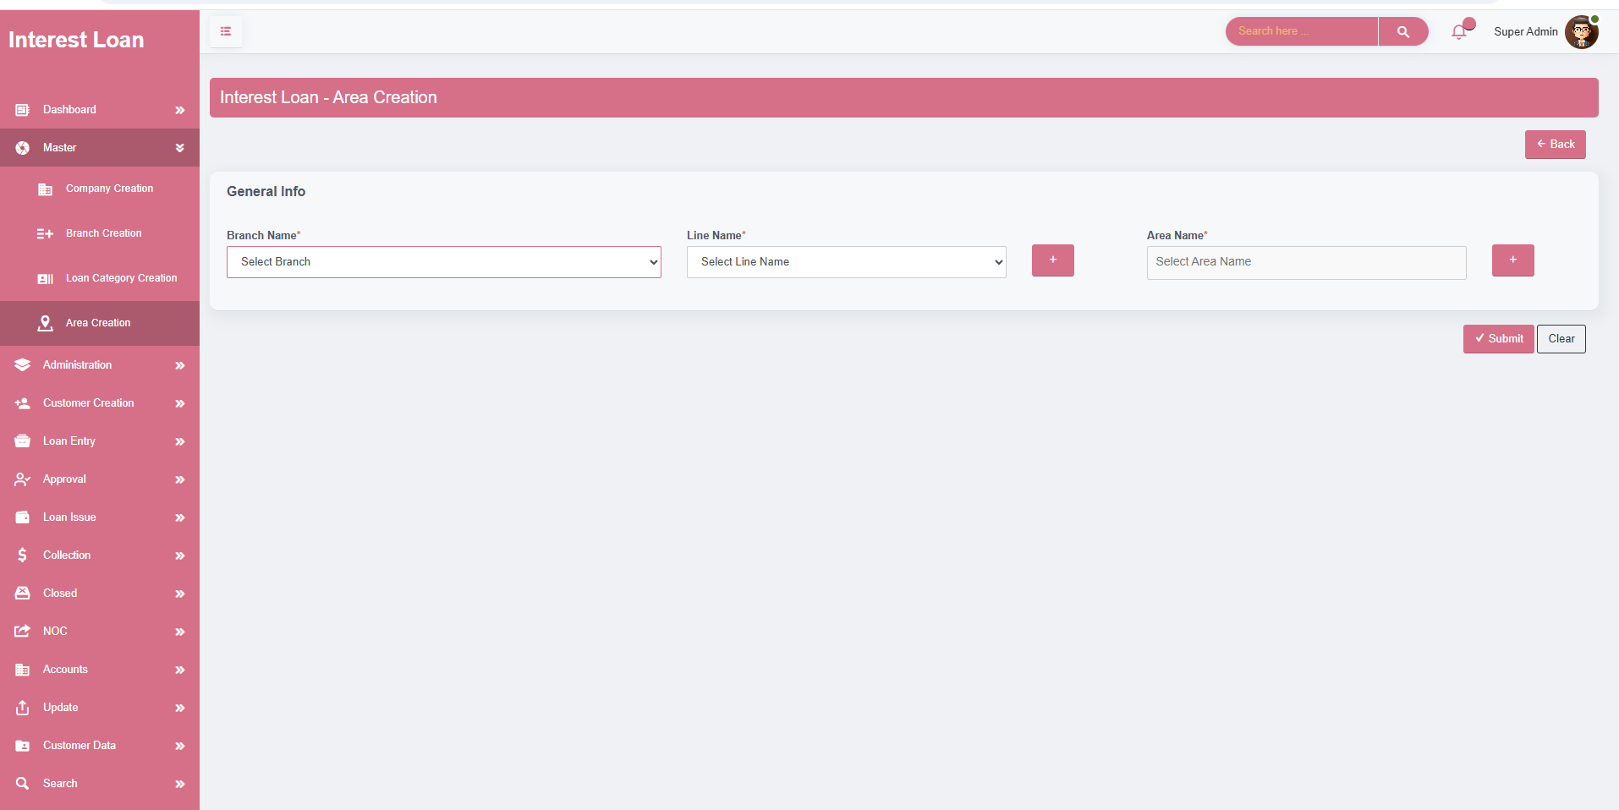

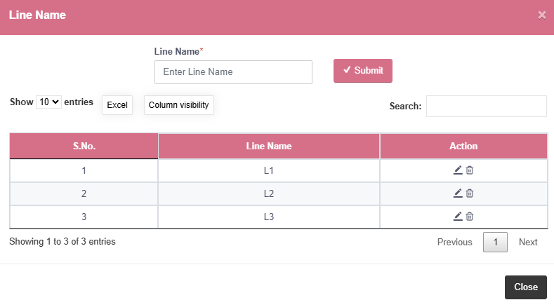

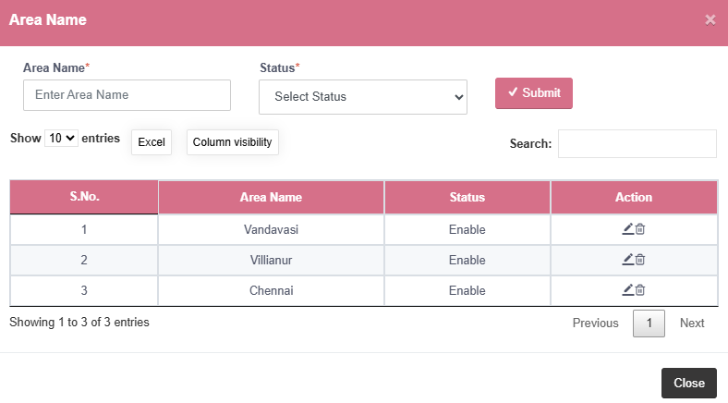

**ADMINISTRATION – BANK CREATION**

* The **Bank Account Creation** module allows you to register and manage bank account details that are linked to specific branches. This setup ensures all financial transactions are accurately routed and associated with the correct organizational branch.
* Allows entry of full **bank name** and its **short name** to clearly identify the financial institution in both formal and abbreviated formats.
* Users must input the **bank account number** and corresponding **IFSC code**, which are essential for verifying account authenticity and enabling online transactions.
* Captures the **branch name of the bank** where the account is held, providing complete information for record-keeping and communication with the bank.
* Optionally supports the upload of a **UPI QR code** image, allowing digital payments and collections via popular UPI apps.
* A dedicated field is available to enter the **GPay number**, supporting fast and tractable digital transactions for businesses that use Google Pay.
* Each bank account must be linked to an **existing organizational branch** using the "Under Branch" field. This ensures that every financial entry is traceable to a specific business location or unit.
* Includes a **Add Bank Creation** option to add fresh bank details whenever a new account is opened or on boarded.
* **Edit** functionality allows administrators to update existing bank information in case of changes like account number updates, IFSC changes, or corrections.
* **Delete** option is available to remove outdated or incorrect bank entries from the system, ensuring the list stays clean and relevant.

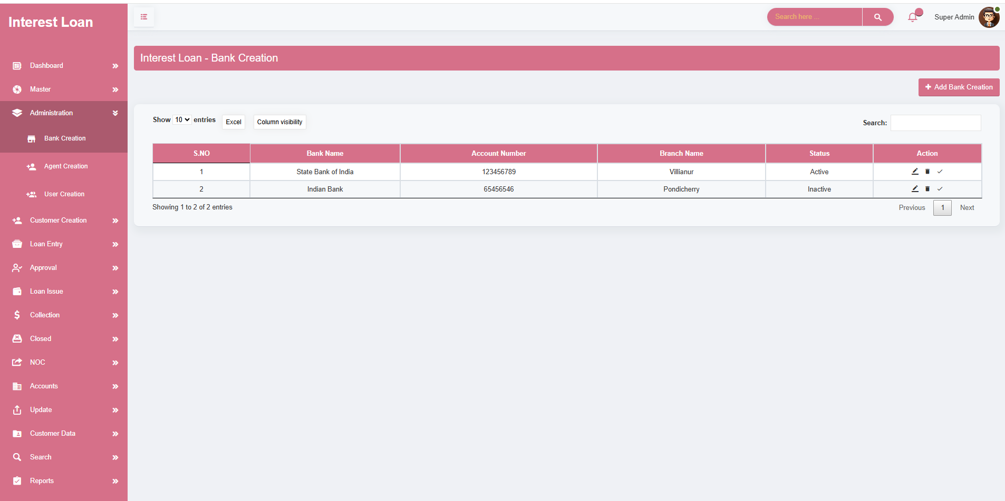

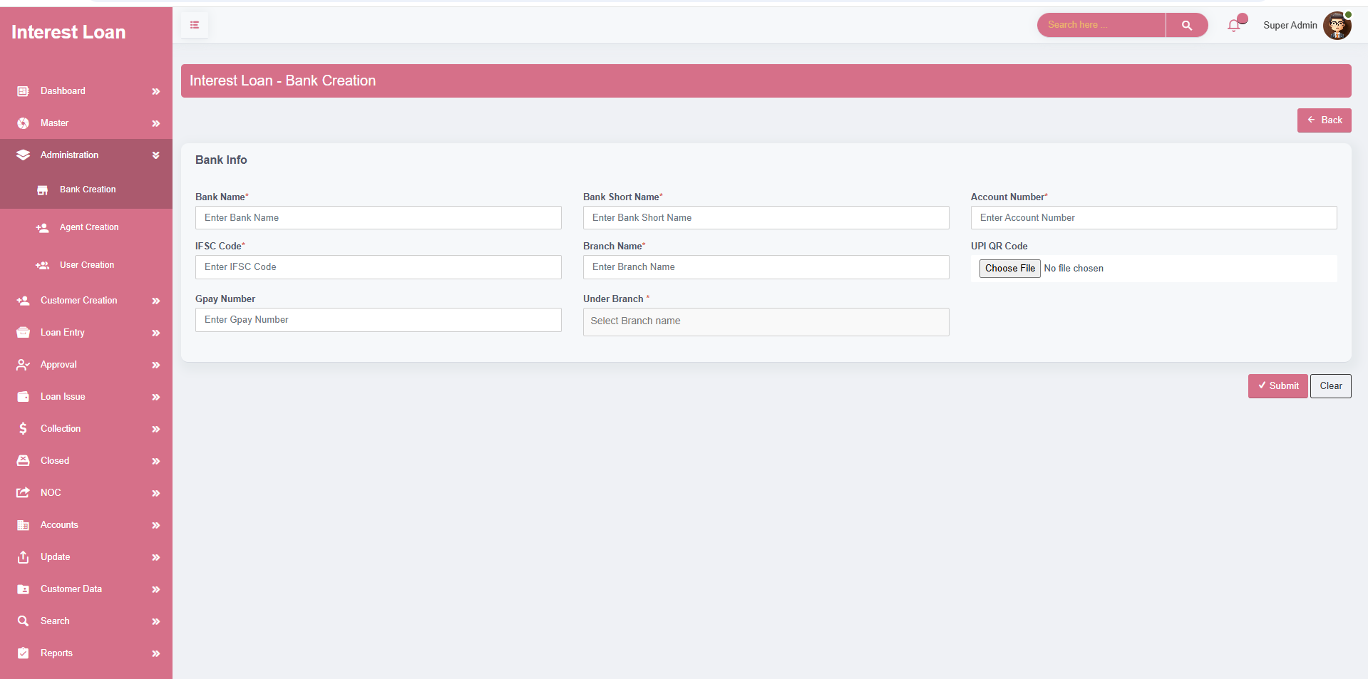

**ADMINISTRATION – AGENT CREATION**

* The **Agent Creation** module is used to register and manage the details of field agents or representatives responsible for handling customers, collections, or field-level operations. It helps the organization maintain accurate records of all agents and their contact information.
* Allows you to register a new agent with a **unique Agent ID**, which helps in tracking and assigning tasks systematically.
* Captures essential personal details such as **agent name** and **primary mobile number**, ensuring reliable communication with field agents.
* Provides an optional field to record a **secondary contact number**, allowing for alternate communication in case the primary number is unreachable.
* Records the **area** in which the agent operates, helping in mapping agents to their respective zones or regions for task allocation and reporting.
* Optionally stores the **occupation or background** of the agent for internal reference or verification purposes.
* Ensures that all agent data is centralized, searchable, and well-organized for better field management and reporting.
* **Includes an Add Agent Creation option** to register fresh agent details whenever a new agent is on boarded or assigned to the organization.
* The **Edit** option allows updating agent details in case of changes to mobile numbers, area assignment, or personal details.
* The **Delete** option is used to remove agent records that are no longer active or needed in the system.

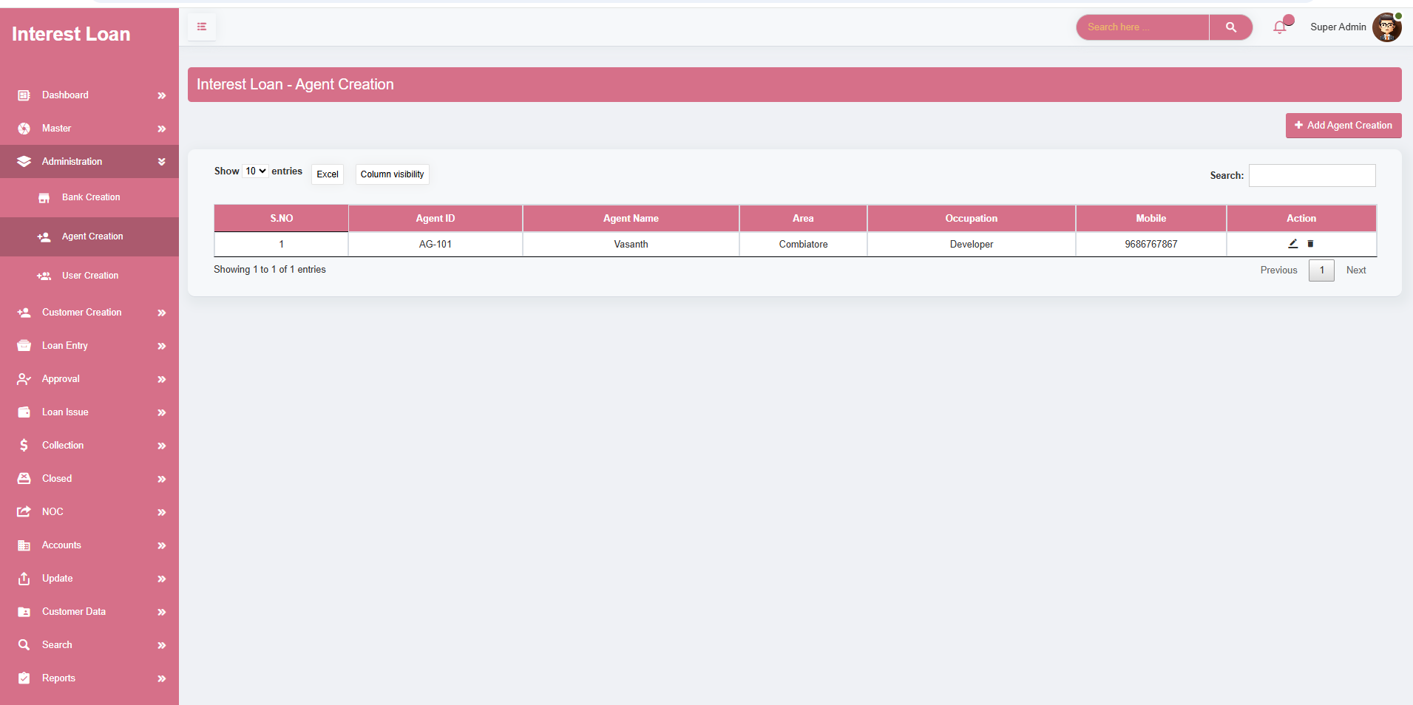

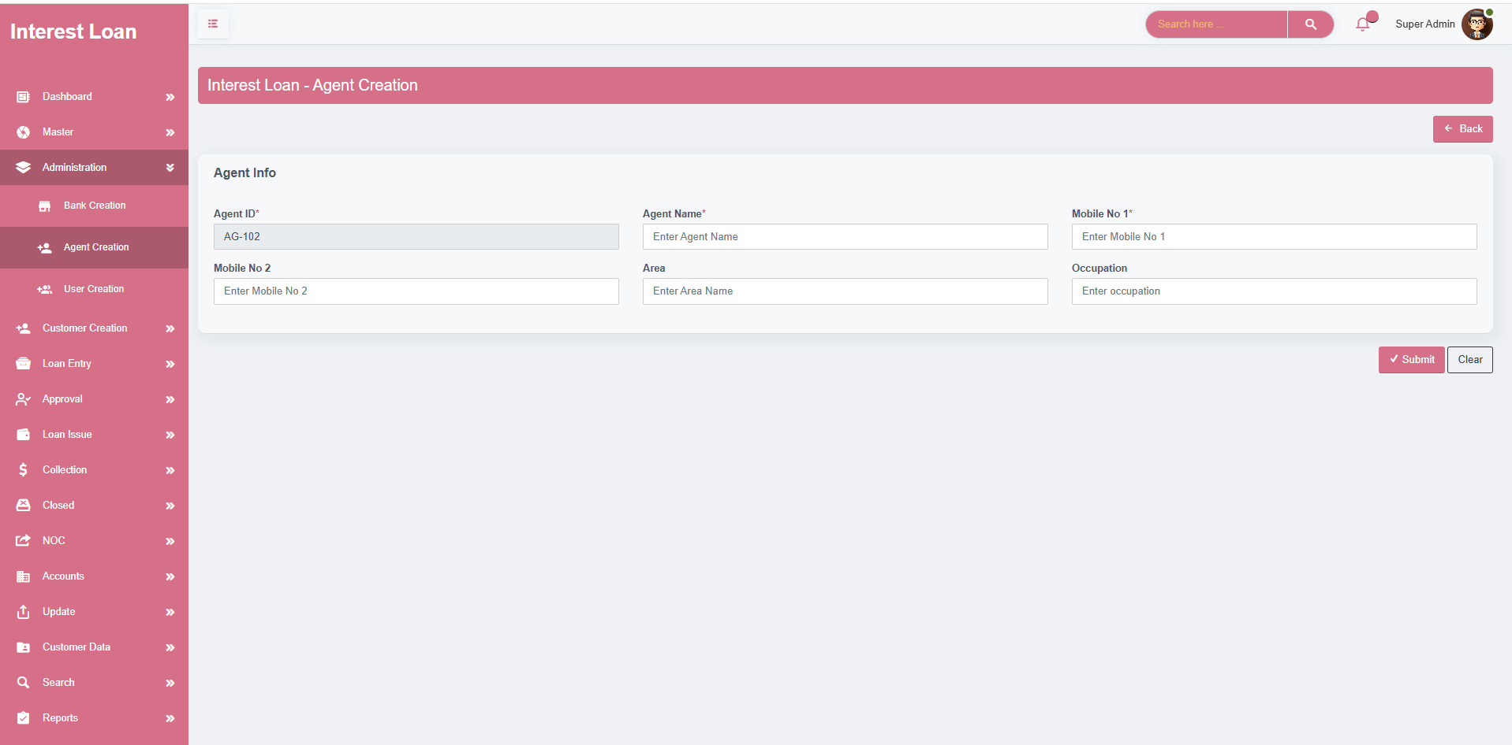

**ADMINISTRATION – USER CREATION**

* The **User Creation** module is designed to register and manage internal users of the application, assigning them roles, login credentials, and access permissions to specific screens or modules. This ensures secure, role-based access control and accountability within the system.
* Facilitates the registration of a new user by capturing essential details like **name, role, designation, address, place, email**, and **mobile number**, helping maintain complete user records.
* Each user is automatically assigned a **unique User ID**, ensuring traceability and preventing duplication.
* Allows setting up secure login credentials by providing a **username, password**, and **confirmation of password**. Each user must have a unique username and a valid password to access the system.
* Supports **mapping users to specific branches, lines, and loan categories**, helping to restrict or customize their access based on operational zones or departments.
* Offers control over **collection access** and **download access**, so administrators can enable or restrict access to sensitive financial operations or data exports as needed.
* **Includes a screen-wise access mapping section**, where administrators can select checkboxes to define which modules and screens the user can access.
* Screens are categorized under groups such as **Dashboard, Master, Administration, Customer Creation, Loan Entry, Approval, Collection, Closed, NOC, Accounts, Reports, Search, and Bulk Upload**.
* This granular control ensures that users only access functions relevant to their roles, improving security and usability.
* **Includes an Add User option** to onboard new users into the system with customized access and branch/role-level control.
* **Edit** functionality allows updating user details, changing access permissions, or resetting login credentials as needed.
* **Delete** option removes inactive or unauthorized user accounts from the system, maintaining security and compliance.

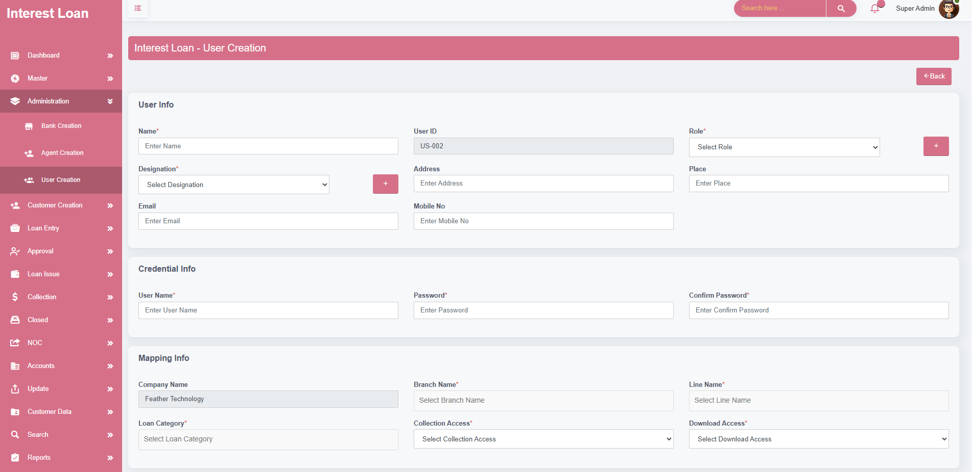

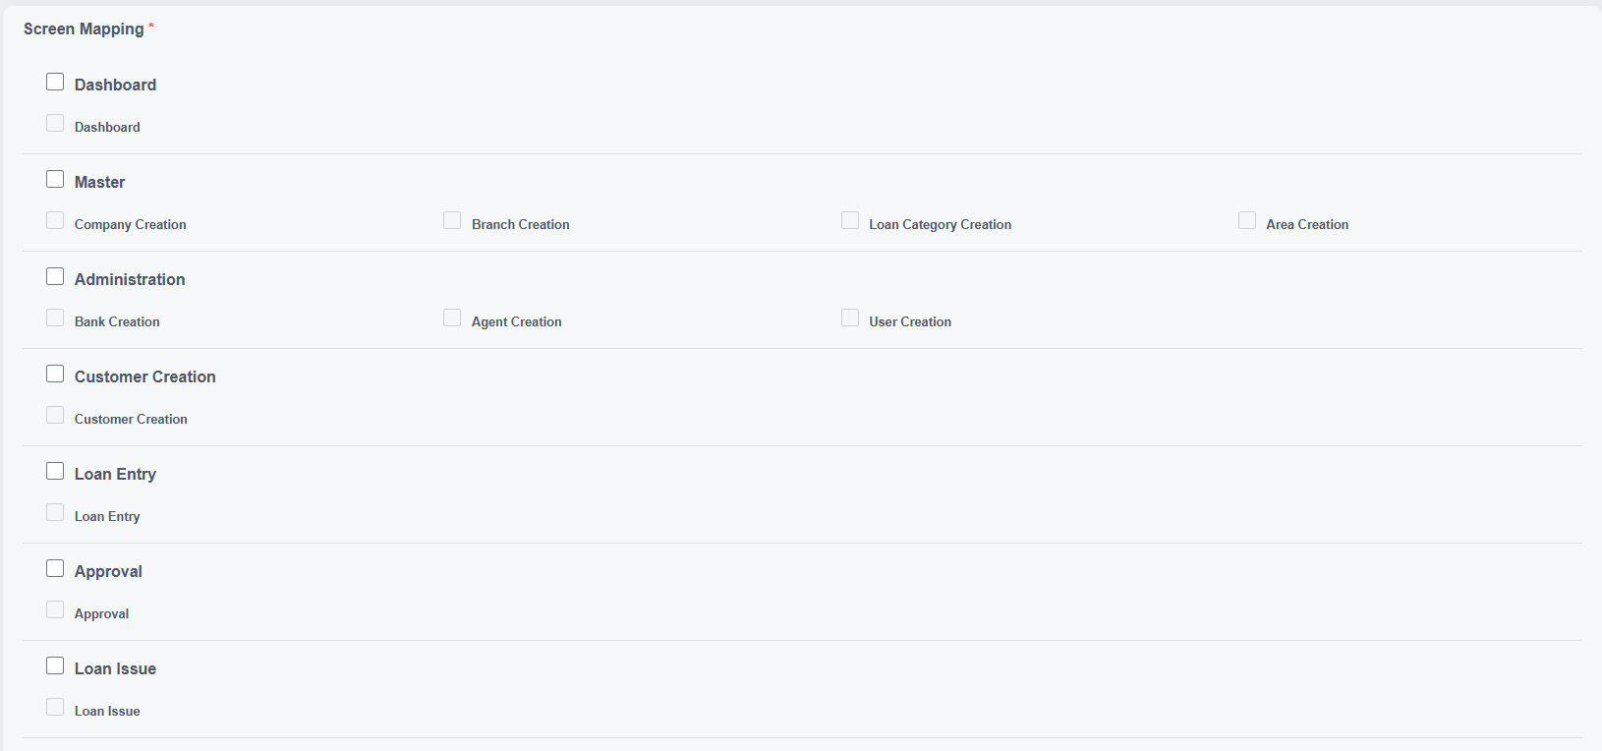

**MODULE NAME – CUSTOMER CREATION**

* The **Customer Creation** module is designed to collect and manage all relevant customer information in a centralized, structured manner. It captures personal, financial, and verification details necessary for processing loans and maintaining compliance with regulatory standards.
* Captures **basic customer details** including a system-generated **Customer ID**, **Aadhar number**, **and full name**, **date of birth**, **age**, **area**, **line**, and **mobile contact numbers**.
* Allows selection of the preferred mobile number for **What Sapp communication**, and records both primary and secondary mobile numbers for better reachability.
* Includes fields for the customer's **occupation** and **occupation details**, helping understand their employment background and financial capacity.
* Records both **current and native addresses**, ensuring traceability and clarity in communication and documentation.
* Supports **photo upload** of the customer to maintain a complete and verified customer profile.
* **Includes an Add Customer Creation option** to register fresh customer details whenever a new is customer to the organization.
* The **Edit** option allows updating Customerdetails in case of changes to mobile numbers, area assignment, or personal details.
* The **Delete** option is used to remove Customerrecords that are no longer active or needed in the system.

FAMILY INFO

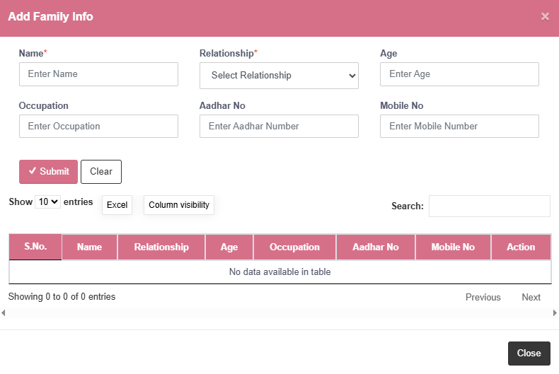

* Let’s users **add family members** along with their name, relationship, age, occupation, Aadhar number, and mobile number.
* Useful for identifying dependents, co-applicants, or guarantors.
* Allows entry of vital information such as family member name, relationship, age, occupation, Aadhar number, and mobile number to maintain a complete family background for the customer.
* **Add** for new family members entries.
* **Edit** to update existing family information if there are any changes.
* **Delete** to remove incorrect or outdated family records.

KYC INFO

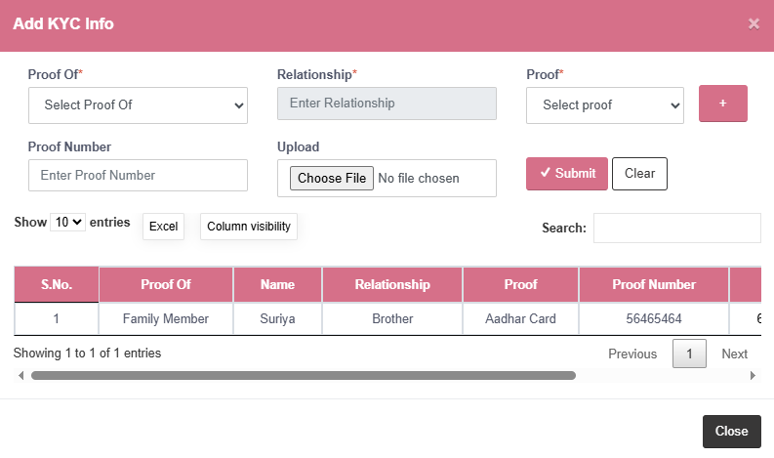

* Collects essential verification data such as proof type, relationship, document type, proof number, and uploaded file.
* Ensures legal and financial compliance.
* **Add** for uploading new KYC entries.
* **Edit** to correct or update proof details.
* **Delete** to remove incorrect or expired proofs.

BANK INFO

* Records complete bank account details including bank name, branch, account holder name, account number, and IFSC code.
* Supports customers with multiple bank accounts if needed.
* **Add** to register new bank details.
* **Edit** to update account information.
* **Delete** to remove inactive or incorrect entries.

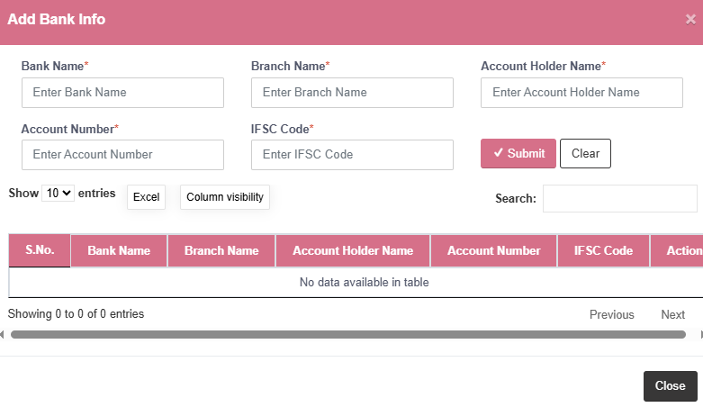  
PROPERTY INFO

* Stores property-related information like property name, description, holder, and relationship to the customer.
* Helps in assessing collateral or asset background.
* **Add** for registering new properties.
* **Edit** to revise details.
* **Delete** to remove invalid property records.

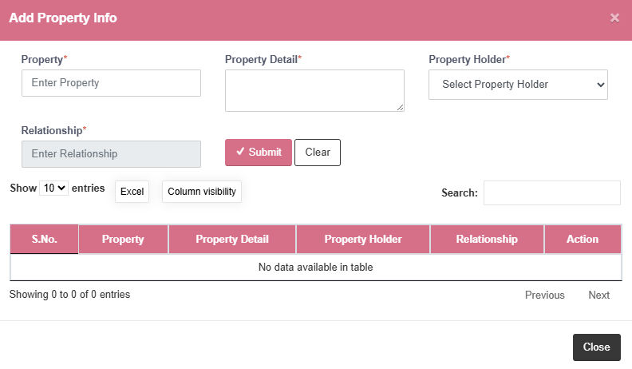

CUSTOMER SUMMARY

* Records the customer's **loan eligibility limit** and any important notes about the customer in the “About Customer” section.

CONCLUSION

* By default, every newly created customer is marked as **"New"** in the system. Once the customer is linked to a **Loan Entry**, their status is **automatically updated to "Existing"**, ensuring accurate tracking of customer activity without manual intervention.

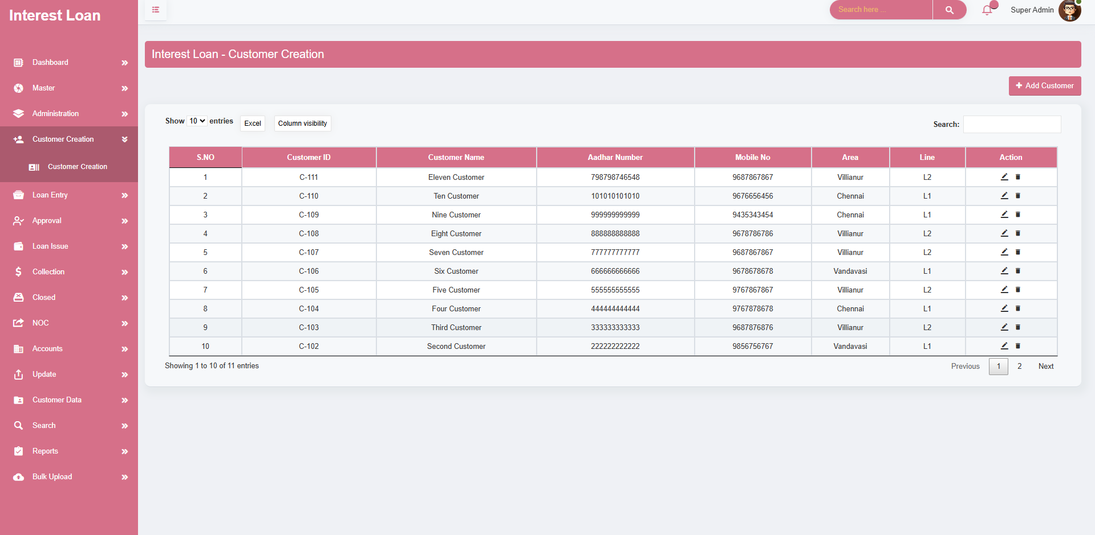

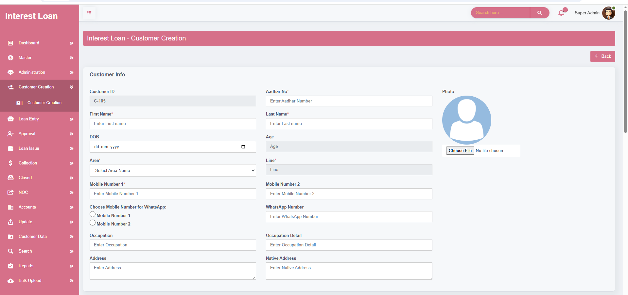

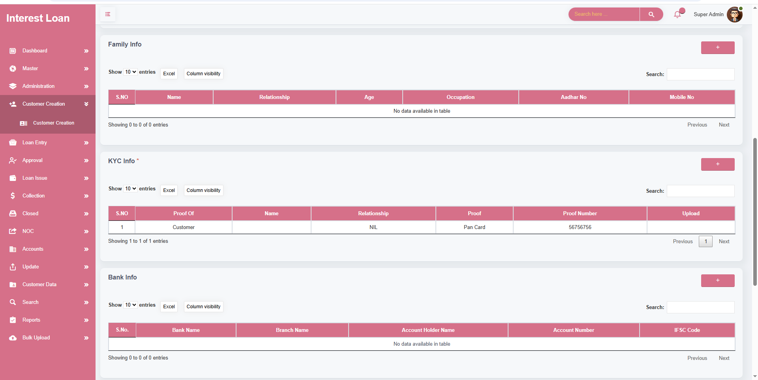

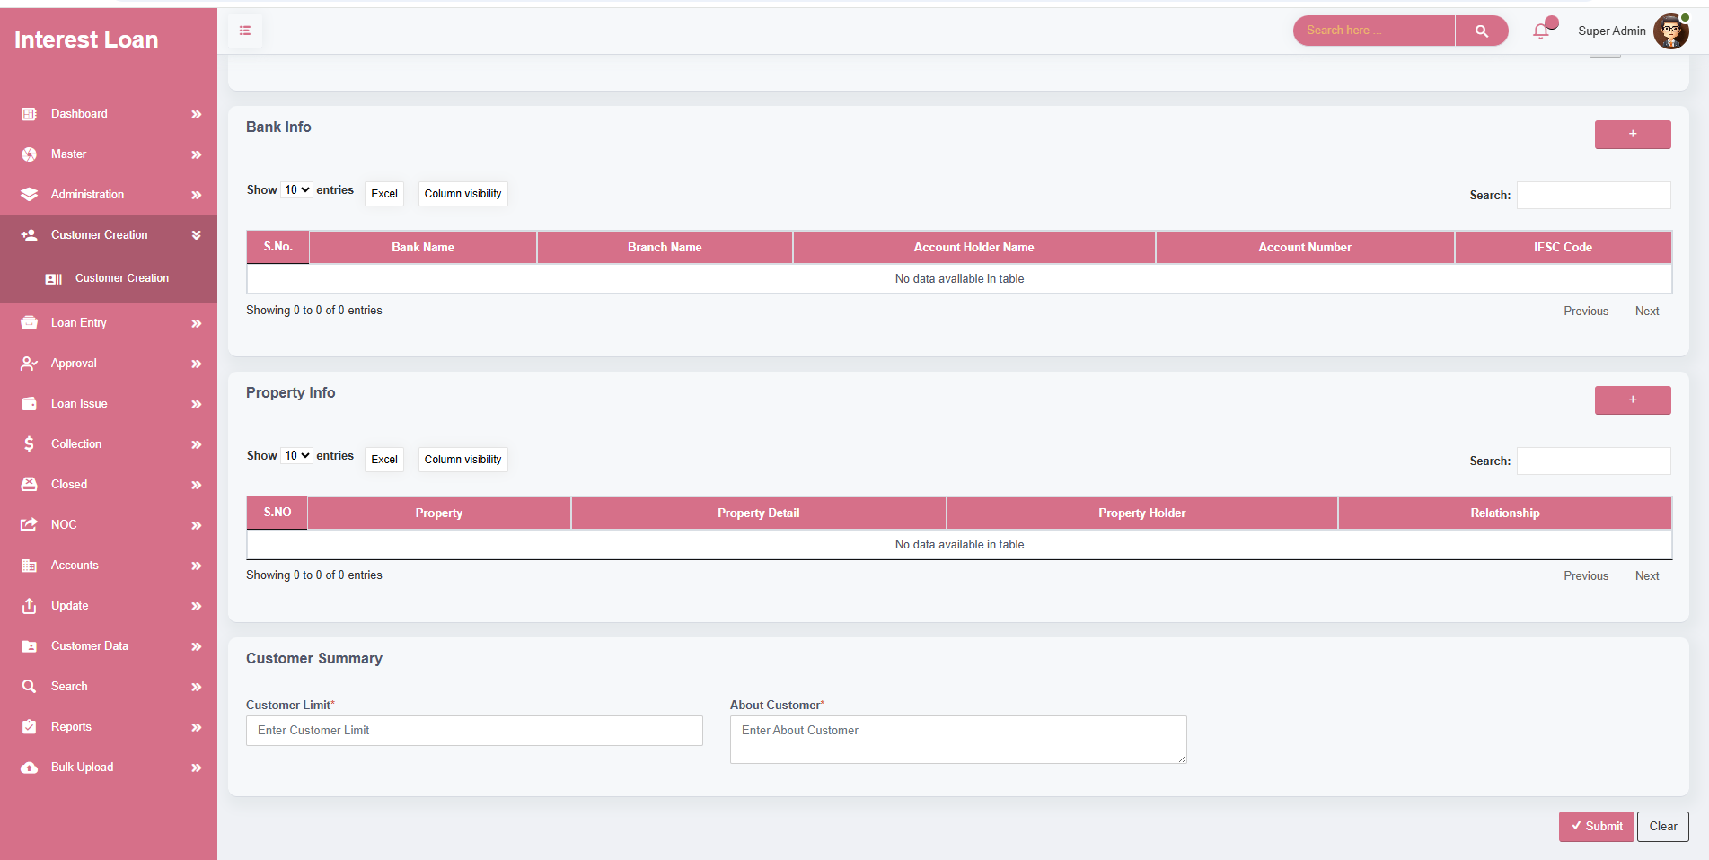

**MODULE NAME – LOAN ENTRY**

CUSTOMER PROFILE

* The process begins by entering only the **Aadhar number** of the customer. If the Aadhar exists in the system, all related customer data is auto-fetched from the **Customer Creation** module, reducing manual entry and ensuring data consistency.
* Users select a **guarantor** from the family info list and define their relationship to the borrower. Guarantor identity is further confirmed through an optional photo upload.

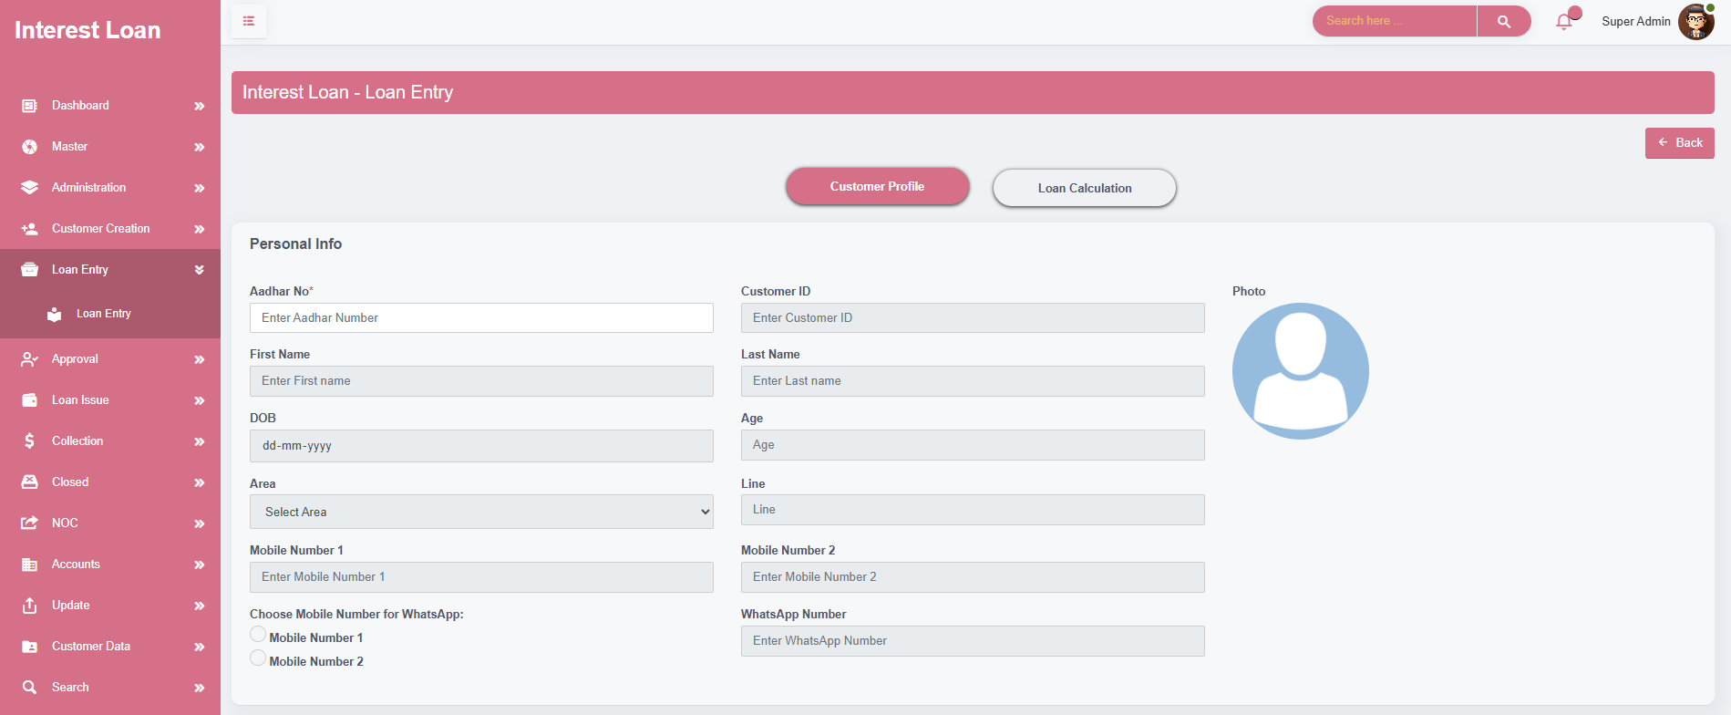

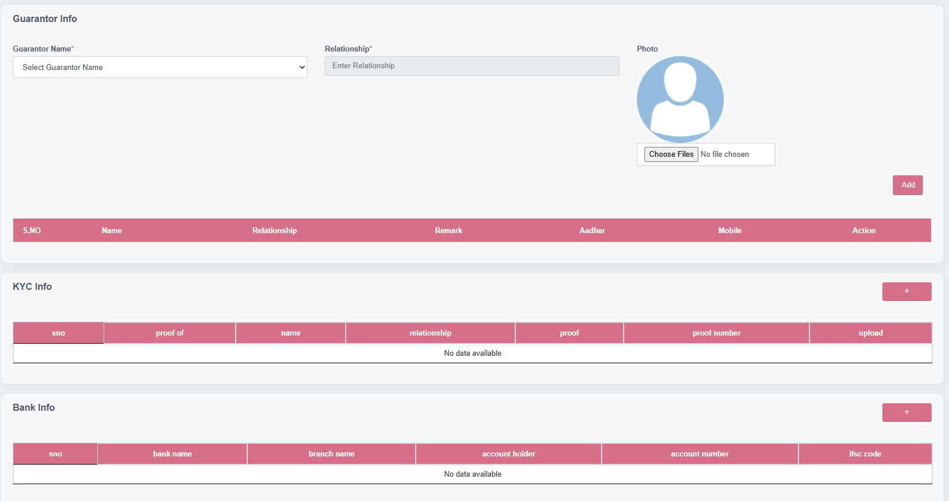

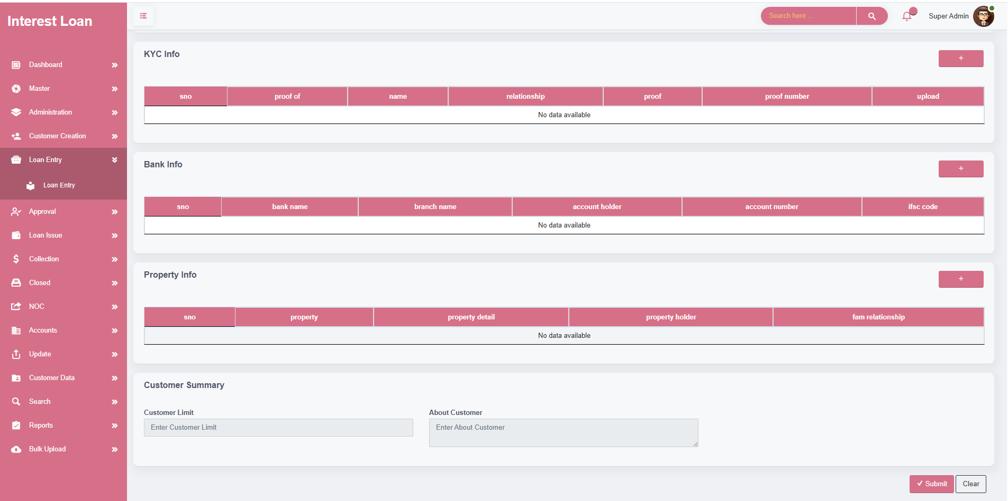

LOAN CALCULATION

* Each loan is assigned an **auto-generated Loan ID** (e.g., **LID-101**) to uniquely identify it across the system. This ID is generated sequentially and cannot be manually modified.
* Once a **Loan Category** is selected, the system dynamically displays the **Loan Calculation section**, showing all related configurations like interest rate, document charges, processing fees, and due periods. If no category is selected, the calculation section remains hidden to avoid confusion.
* A **Calculate button** is provided to perform calculations based on the loan amount and category settings. It displays key financial outputs such as:
* Net cash to be disbursed (after deductions) , Interest amount , Document and processing charges
* The system also generates a **maturity date** based on the due start date and selected repayment period.
* The **Agent Info** section includes a **"Referred by Agent"** option. If "Yes" is selected.
* **Agent Name** dropdown is displayed. No means no need for agent.
* Upon selection, the system **auto-fills the Agent ID** (e.g., **AG-102**) based on the linked agent record
* Users can **upload supporting documents** related to the loan, such as signed agreements or customer declarations.
* Validated Fields are Must. Then only submit. Otherwise its show alert message please fills out mandatory fields.
* **Add** – Create a new loan entry by entering the customer's Aadhar, selecting the loan category, performing calculations, and submitting the entry.
* **Edit** – Modify any previously created loan entry, provided it has not yet been approved or issued.
* **Delete** – Remove an incorrect or duplicate loan entry. Deletion is restricted based on user roles and loan status.
* Once all required details are completed, clicking the **"Move"** button forwards the loan to the **Approval Screen**, officially submitting it into the loan workflow.

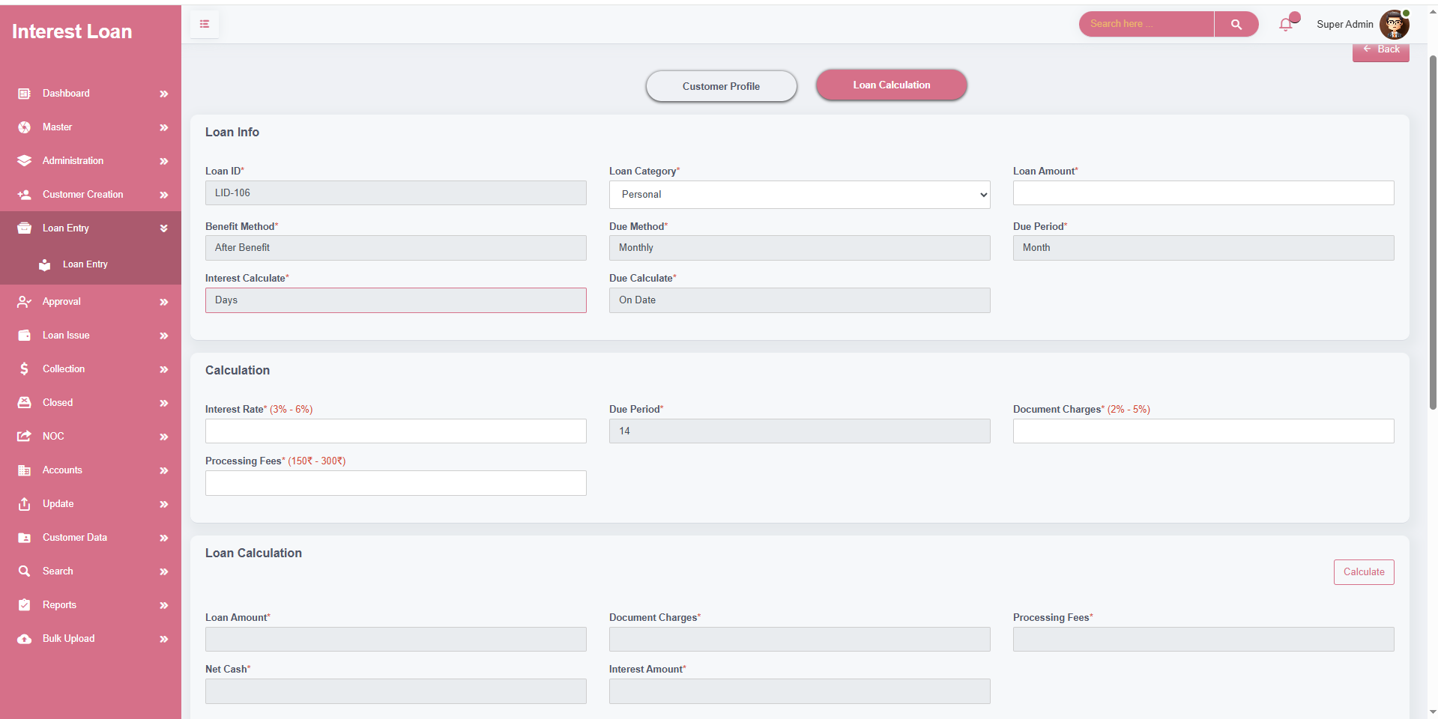

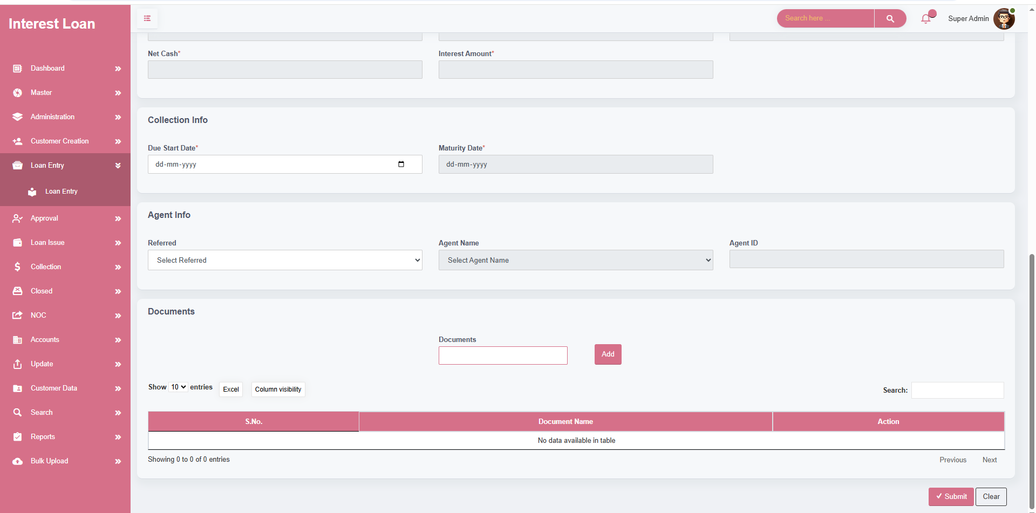

**MODULE NAME – APPROVAL**

* The **Approval module** is the second stage of the loan lifecycle, used to verify and authorize loan applications submitted through the Loan Entry section. This stage ensures that all financial and eligibility constraints are validated before the loan can be issued.
* The Approval process loads all loans that have been submitted from **Loan Entry** but not yet approved
* This section is functionally similar to Loan Entry, displaying complete loan information such as customer details, guarantor info, loan configuration, and calculated values
* Before a loan can be approved, the system performs **three critical validations**:

Loan Category Limit Check:

* If the **loan amount** entered exceeds the **loan limit defined in the Loan Category**, the system blocks the approval and shows the alert: "Enter Lesser than Loan Limit"
* This ensures that loans stay within the predefined risk boundary of the financial product.

Customer Limit Presence Check:

* If the **customer limit** has not been entered in the Customer Profile, the system will prevent approval and show: "Kindly Enter The Customer Limit"
* This is mandatory to assess borrower eligibility

Customer Limit vs. Loan Amount Check:

* If the **loan amount** is greater than the **customer's assigned limit**, approval is blocked and the following message appears: "Customer limit is less than the loan amount. Please update either the customer limit or the loan amount."
* Only when **all three conditions are satisfied**, the **Approve button** becomes active, allowing the loan to proceed to the next phase – **Loan Issue**.
* **Edit** – Modify any previously created loan entry, provided it has not yet been approved or issued.
* **Cancel** – Allows authorized users to cancel the current loan approval process, typically used when a loan application needs to be rejected or removed from workflow.
* **Revoke** – This action is used to reverse a previously approved loan. It changes the loan status back to the pending stage, allowing for corrections or re-evaluation.

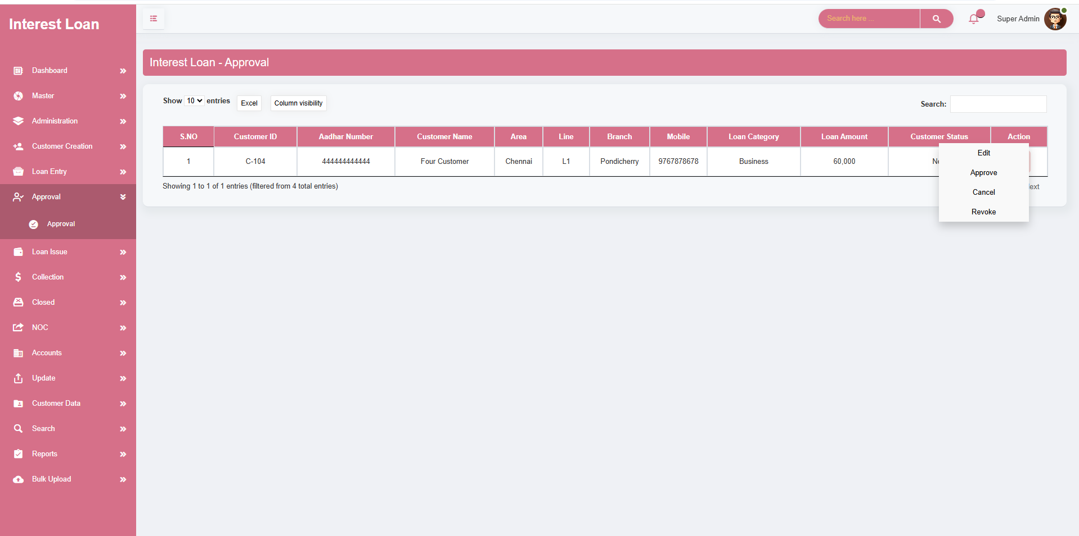

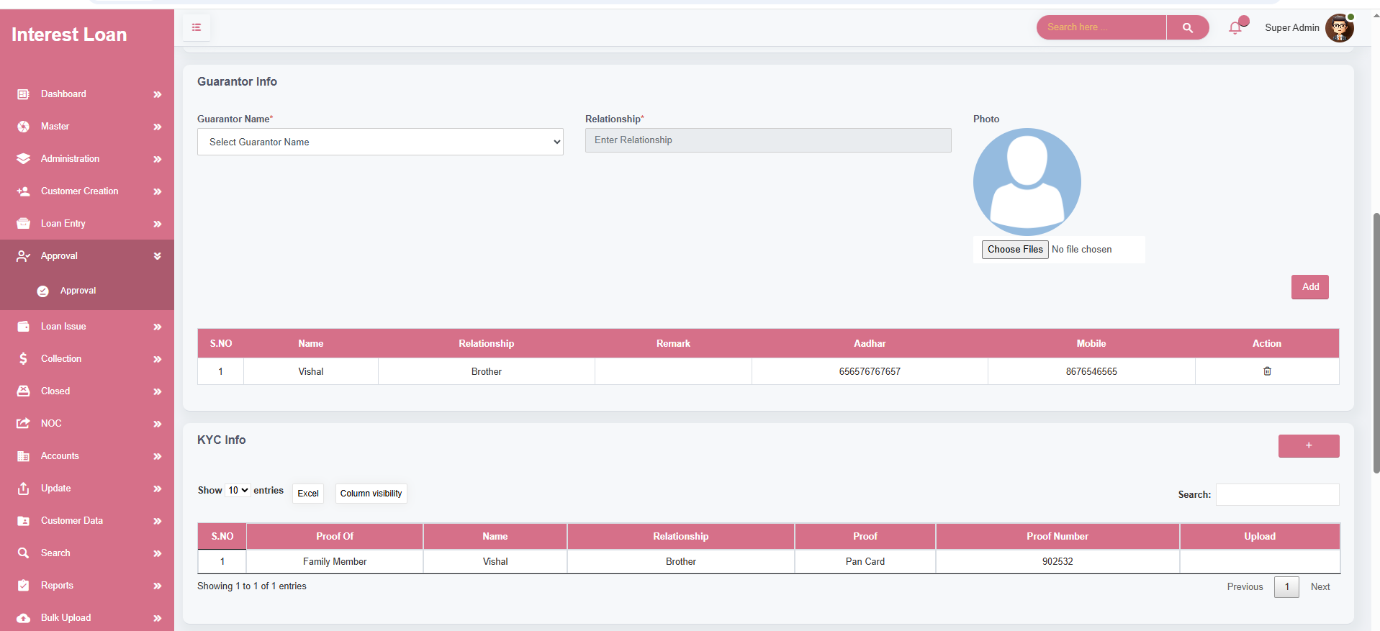

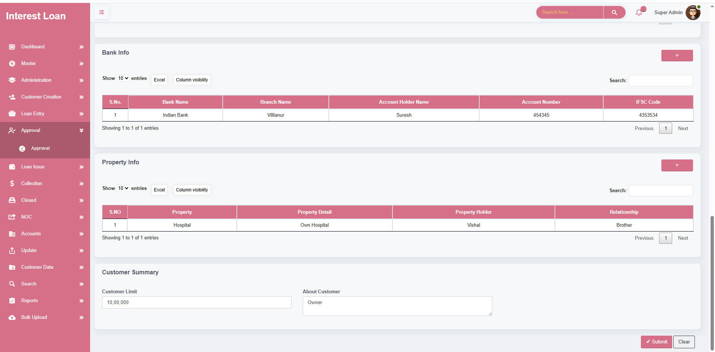

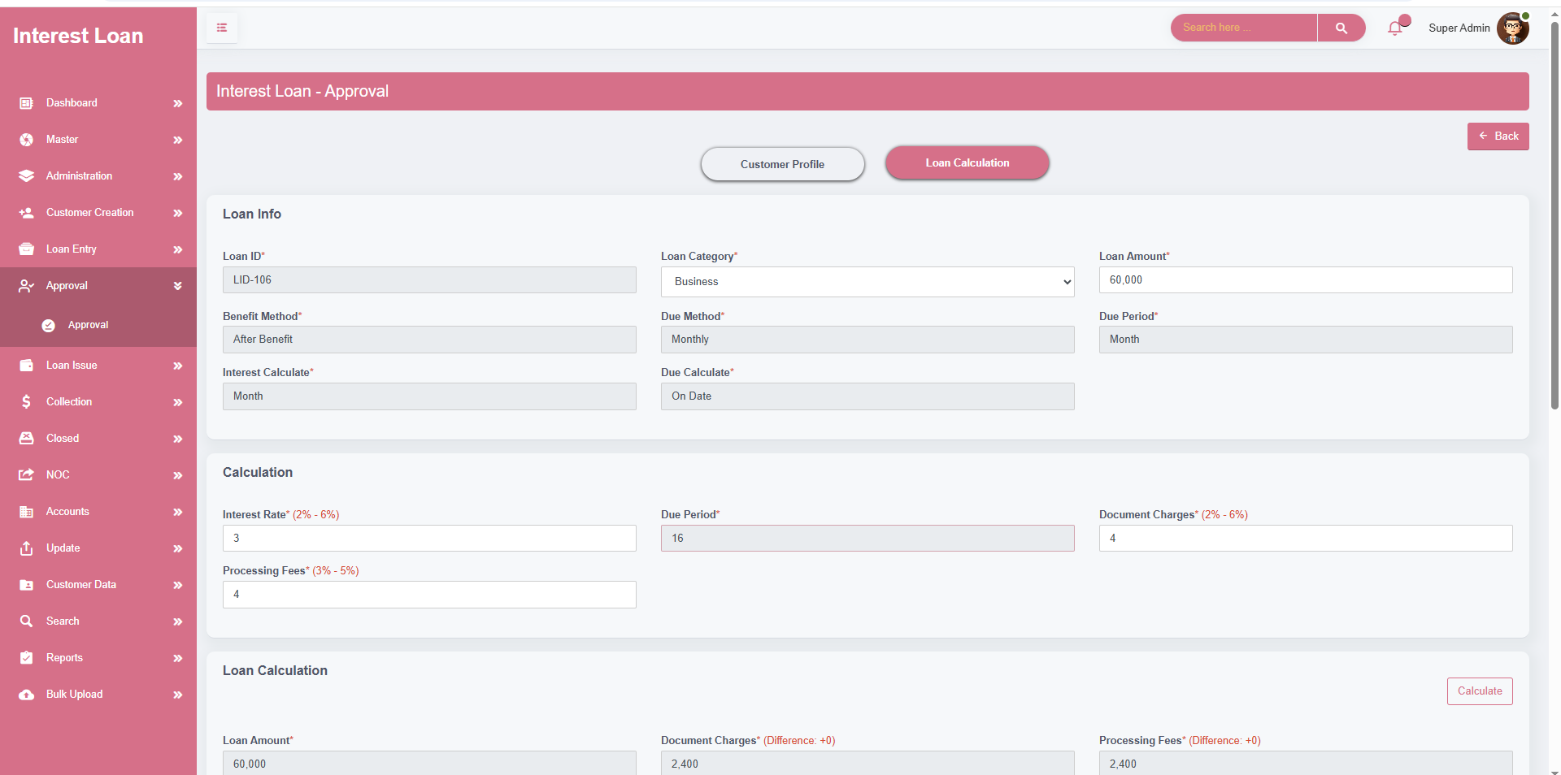

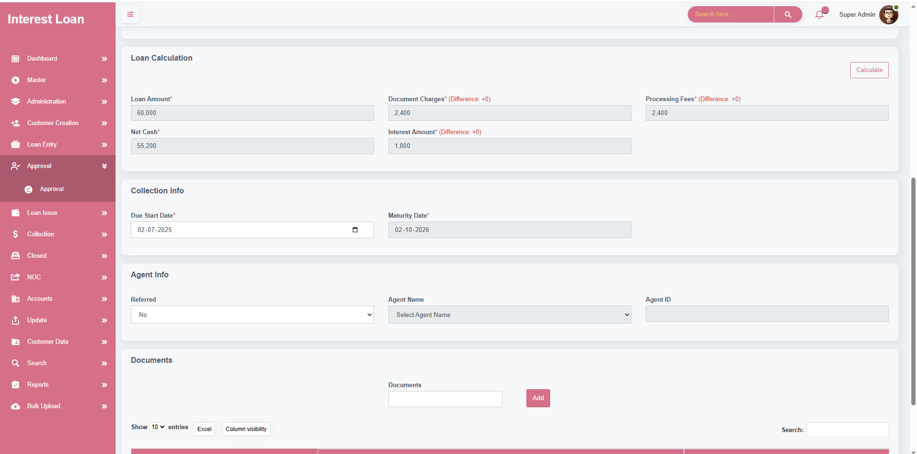

**MODULE NAME – LOAN ISSUE**

* The **Loan Issue module** is the final stage in the loan lifecycle where the approved loan is officially disbursed to the borrower or guarantor. This section is divided into **two key parts**: **Documentation** and **Loan Disbursement**. It ensures that all required legal and financial documents are submitted before releasing the loan amount.
* The **Loan Issue** screen finalizes the disbursement of approved loans by managing payment methods (cash, bank transfer, or cheque) and issuing funds to the designated recipient—either the customer or guarantor—after completing mandatory documentation.

Documentation

* The **Documentation** section captures all necessary legal and security documents associated with the loan. This section is only visible if the **Loan Category** includes documentation requirements. If documentation is not enabled, this section remains hidden.

CHEQUE INFO

* Captures post-dated or security cheques.
* Requires holder type, holder name, relationship, associated bank, number of cheques, and document upload.

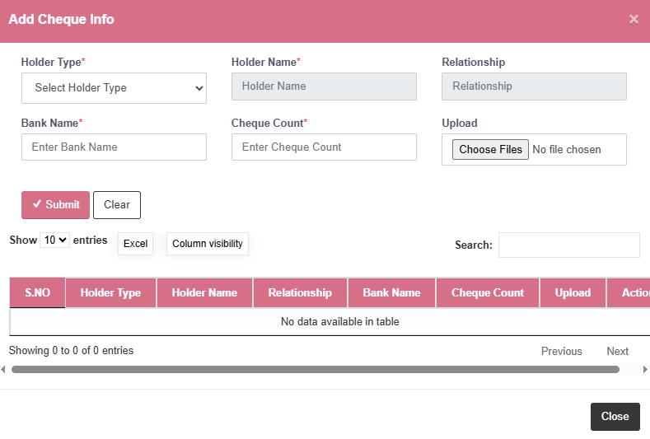DOCUMENT INFO

* Uploads general loan-related documents.
* Requires document name, type, holder name, relationship, and upload.

MORTGAGE INFO

* Captures information about property pledged as mortgage.
* Includes property holder details, relationship, property description, registration details, mortgage value, and upload.

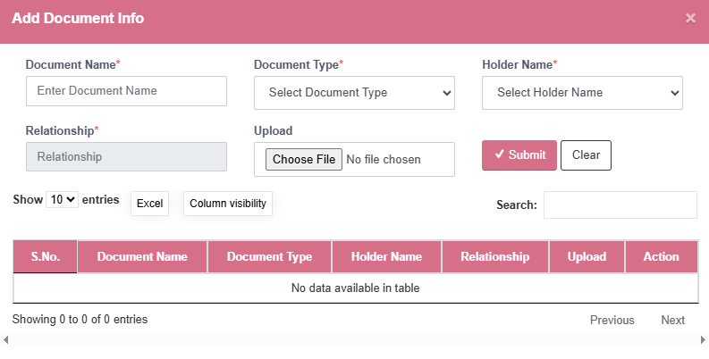

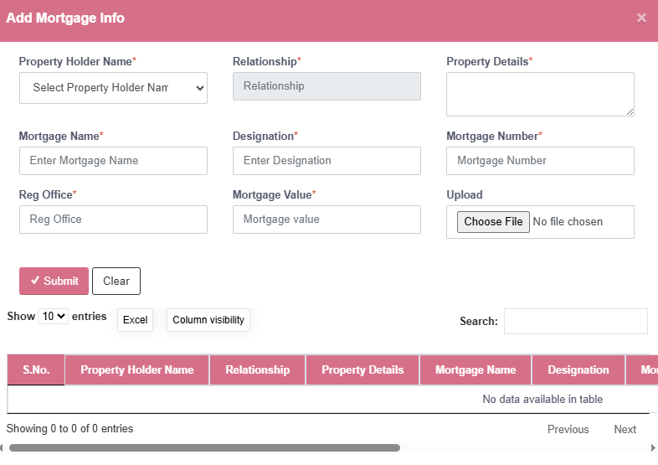

ENDORSEMENT INFO

* Used for loans involving vehicles.
* Includes vehicle owner, relationship, vehicle info, endorsement name, original key and RC ownership, and upload.

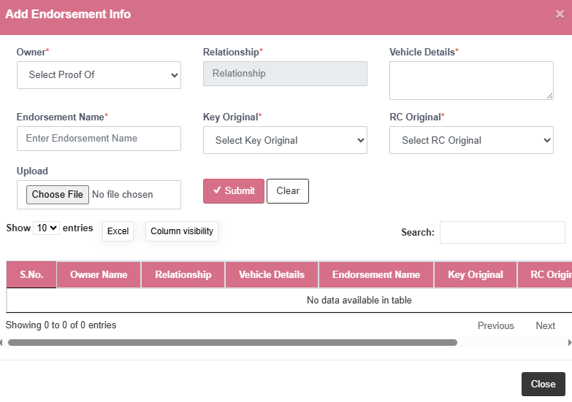

GOLD INFO

* Used for loans backed by gold
* Captures gold type, purity, weight, and calculated value

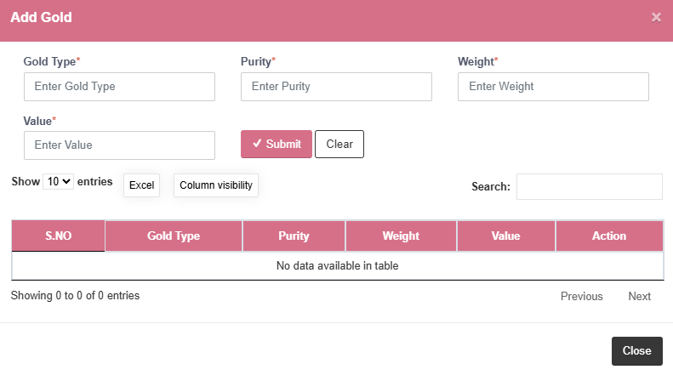

* Each sub-section ( Cheque , Document , Mortgage , Endorsement , Gold )
* **Add** – To input new data entries.
* **Edit** – To modify existing entries when updates are required
* **Delete** – To remove incorrect or outdated records.

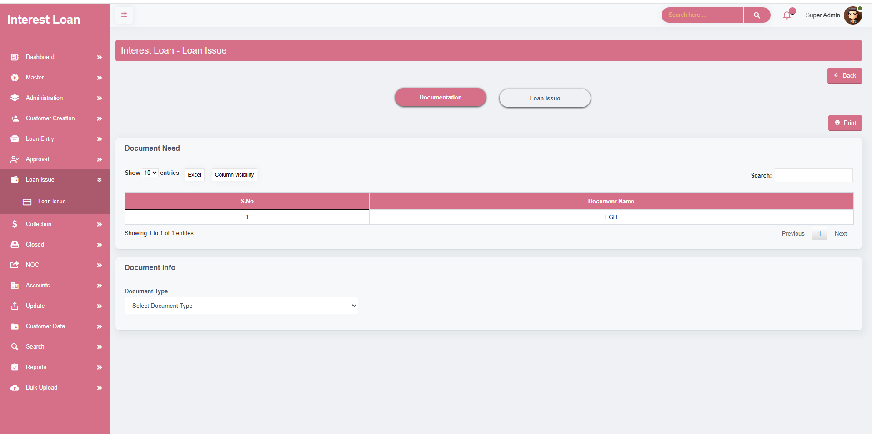

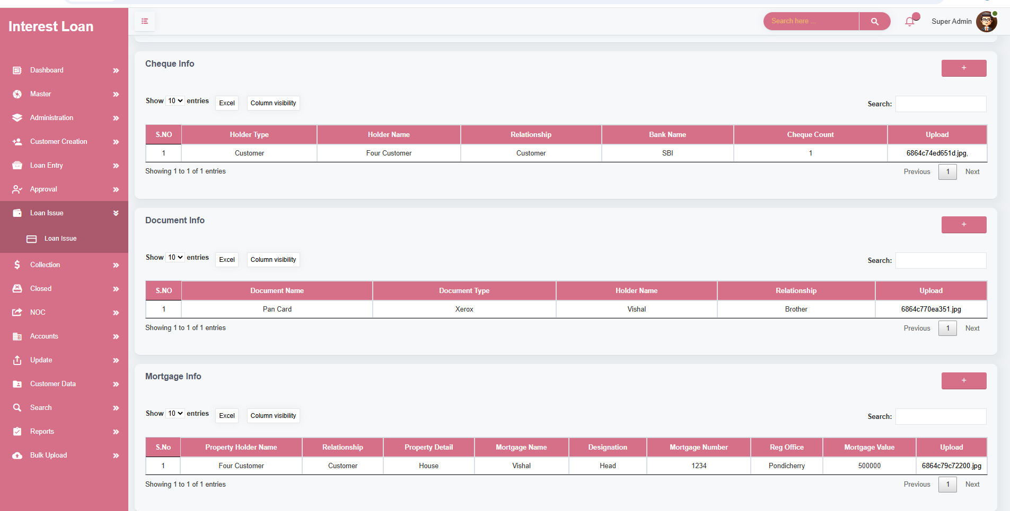

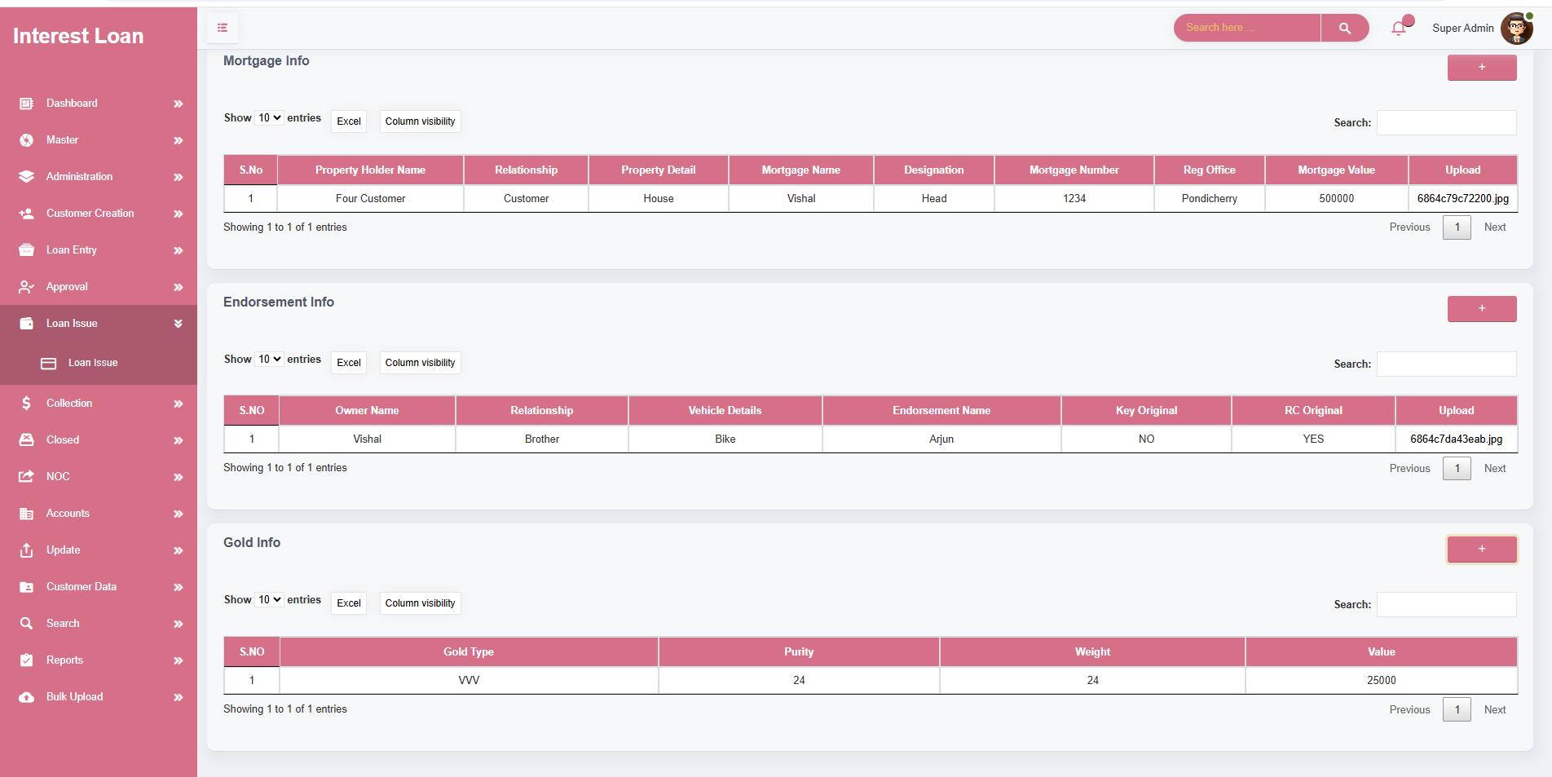

LOAN ISSUE

* Payment Type Options
* **Single Payment** – The full loan amount is disbursed in one transaction.
* **Split Payment** – The loan amount can be disbursed in multiple installments. Split values and dates must be specified.
* Payment Modes
* **Cash** – Once paid amount automatically show balance amount.
* **Bank Transfer** – Bank name, Transaction value, Transaction remark.
* **Cheque** – Bank name, Cheque value, Cheque remark.
* **Issue Recipient** – The loan can be issued to either the: Customer or Guarantor.
* Recipient selection is based on predefined terms during loan approval or customer instruction.

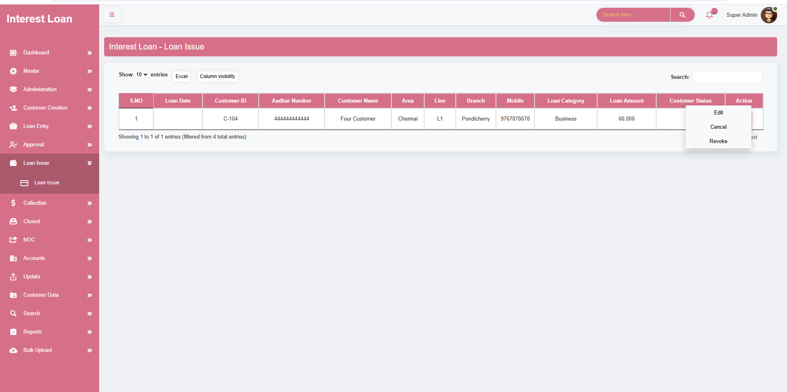

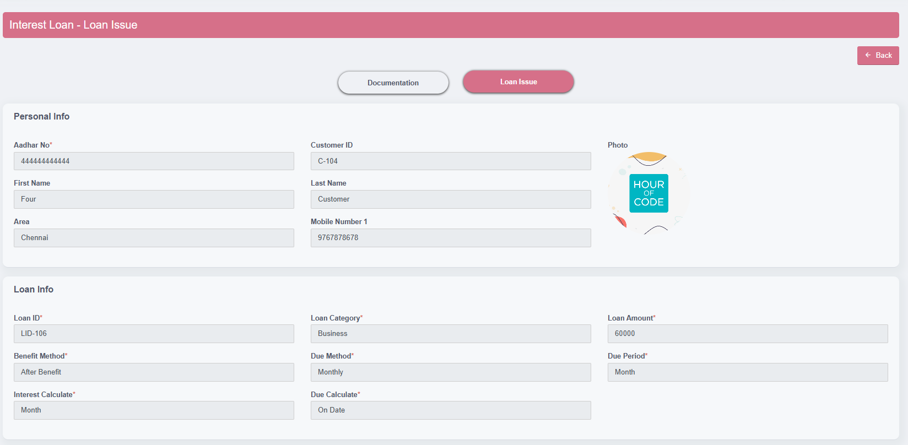

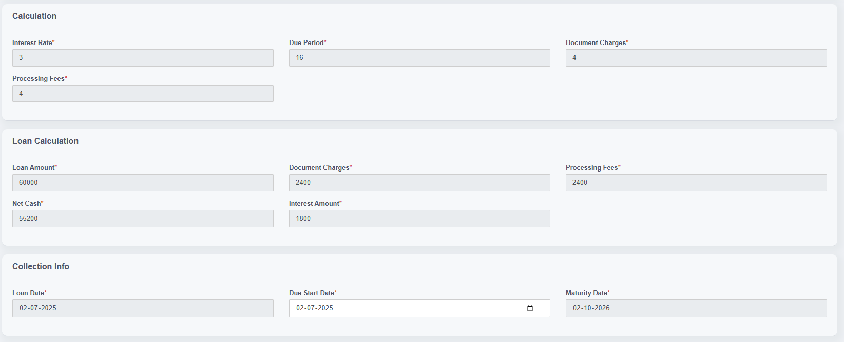

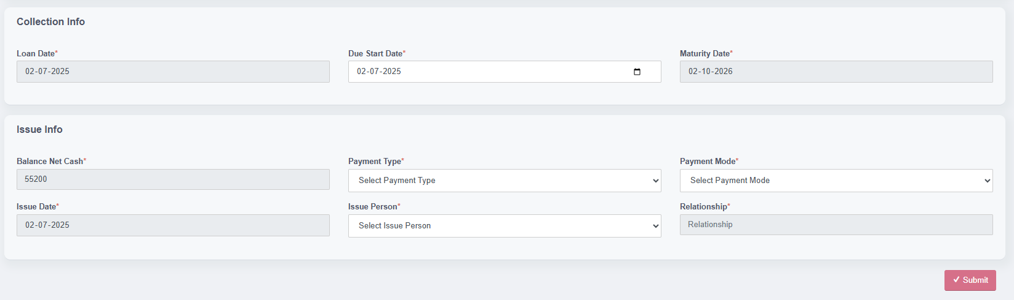

**MODULE NAME – COLLECTION**

* The **Collection Module** facilitates the process of collecting EMIs, penalties, and fines from customers who have active loans. It also provides detailed breakdowns of the amounts due and tracks all previous and current payments.
* When a user or selects a customer's Aadhaar number, the system fetches and displays customer details along with a list of all active loans.
* Each loan displays key info like loan ID, category, date, amount, balance, and current status with options to view charts or proceed with collection actions.
* If the user has collection access (configured in User Creation), they can perform collection activities; otherwise, collection features are hidden or view-only.
* The available actions for each loan are **"Pay Due"** (for regular repayment) and **"Pay Fine"** (if fine needs to be cleared separately).
* On selecting "Pay Due", the system calculates and shows all relevant amounts: interest, principal, penalty, fine, pending, and total payable.
* The user must enter paid amounts, and the system tracks and allocates them towards interest, penalty, fine, and principal accordingly.
* A separate section is available for applying **waivers** (interest, penalty, fine, and principal) — this is only visible to users with waiver access.
* The **collection mode** (cash or bank transfer) and **collection date** are mandatory to finalize a payment.
* Each transaction is tracked using a **Collection ID** which is auto-generated by the system.
* There are **three chart views** available per loan:
* **Due Chart**: Shows month-wise EMI breakdown and payment status.
* **Penalty Chart**: Shows penalty dates, paid/balance amounts, and waivers.
* **Fine Chart**: Shows fine details, purpose, and waiver history.
* Collection data cannot be edited by unauthorized users. Users with the right permissions can **edit or delete** collection records as needed.
* If any data is missing or conditions are not met, system will prompt alerts to guide the user (e.g., missing amount, unpaid balance, or invalid waiver entry)

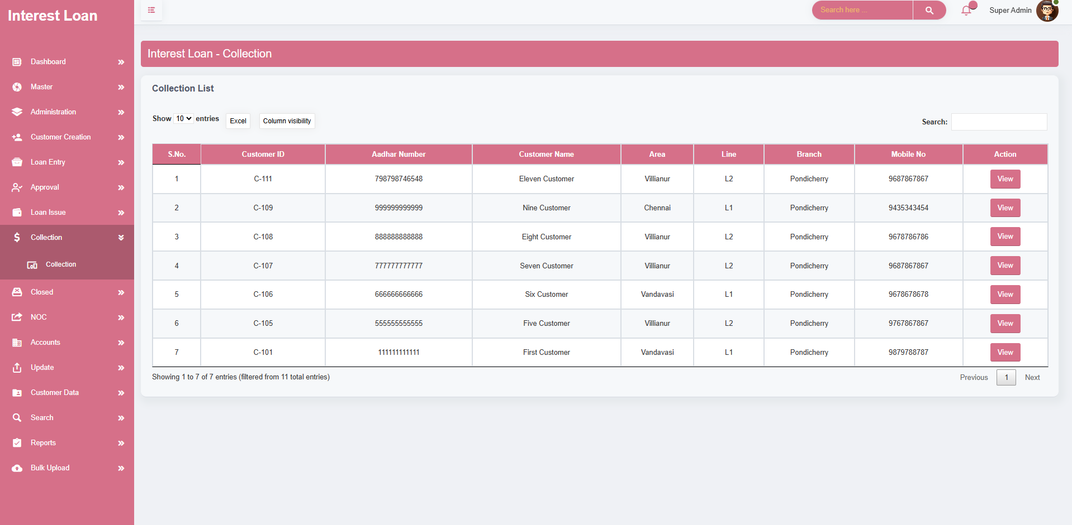

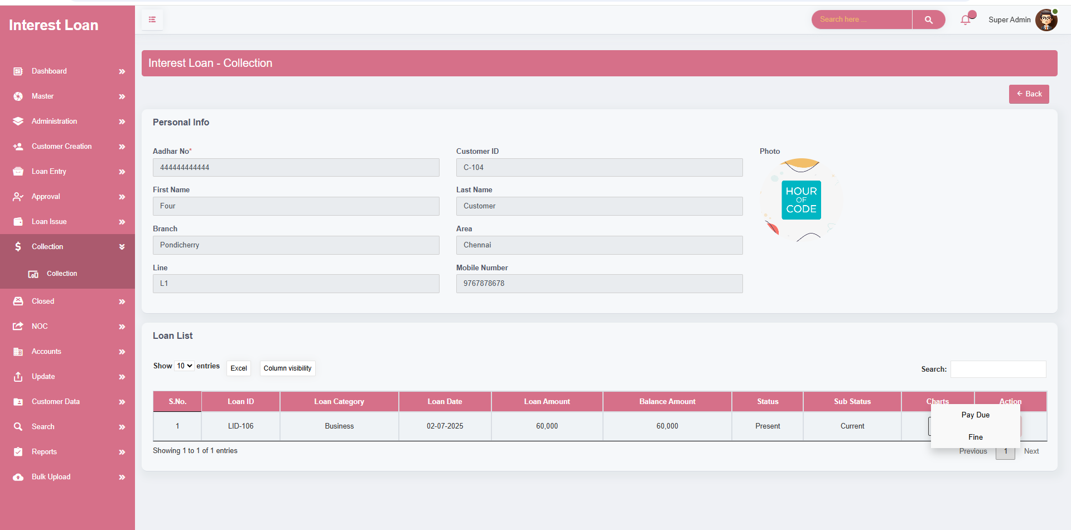

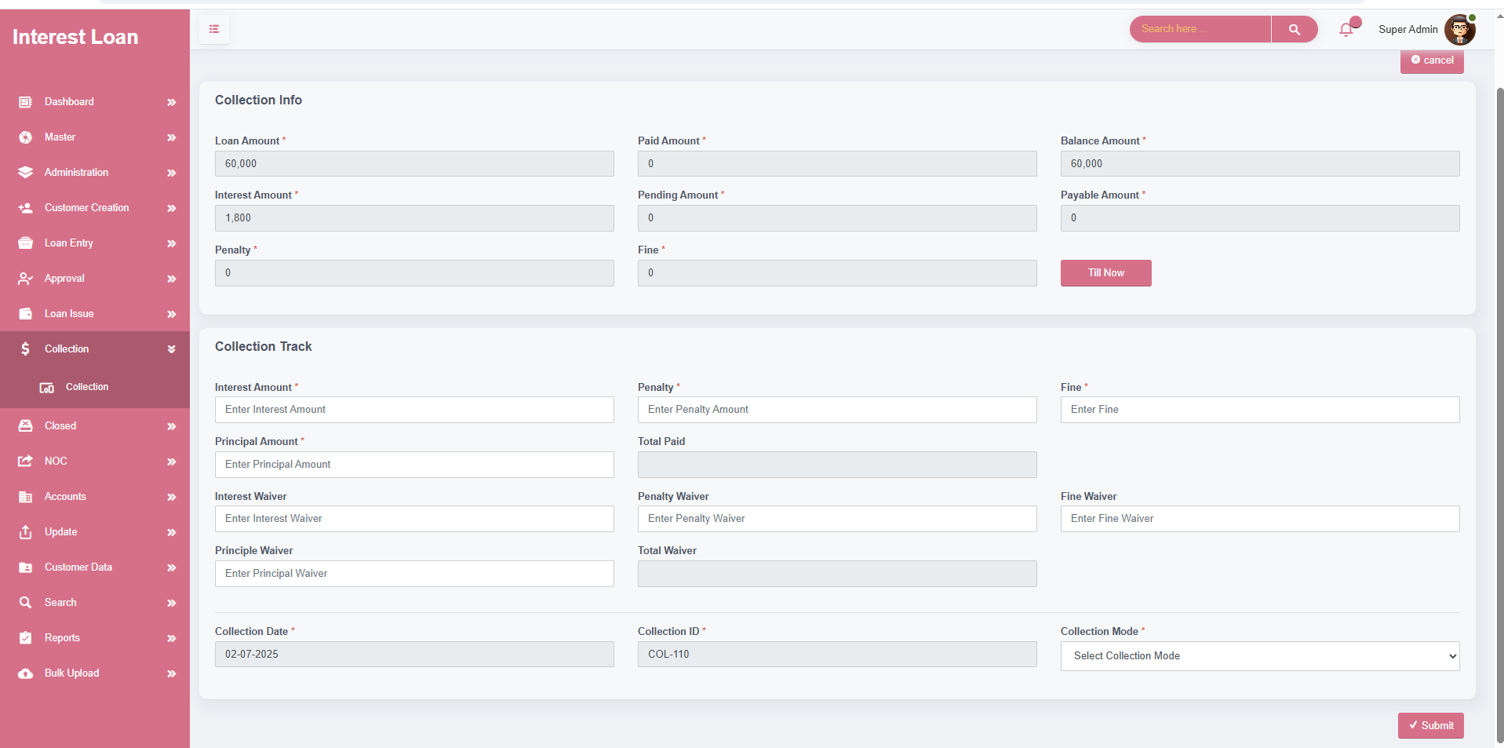

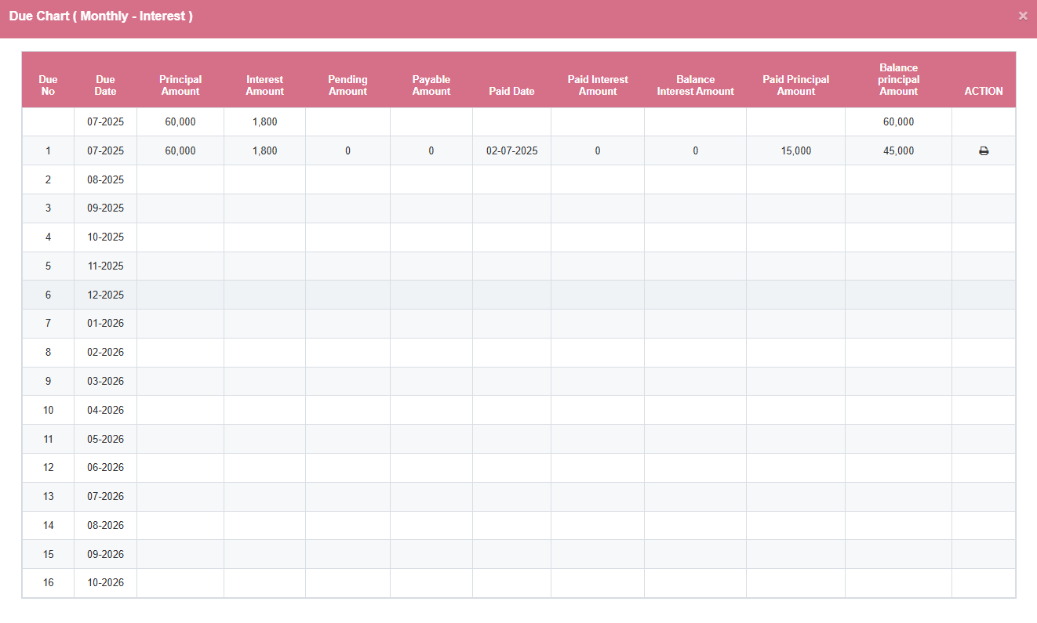

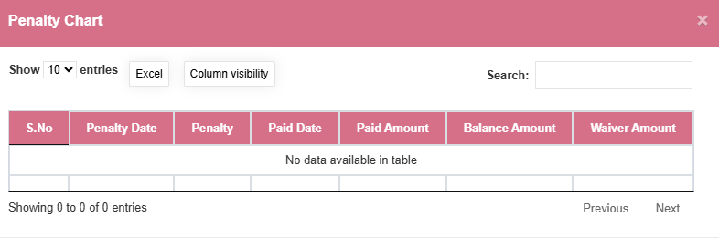

* The **Penalty Chart** in the Collection screen is designed to systematically manage and monitor penalties imposed due to overdue loan payments.
* It provides a detailed breakdown of penalty-related data including **penalty date**, **amount**, **paid date**, **balance**, and any **waivers** applied.
* Penalties are **automatically generated** based on missed payment deadlines

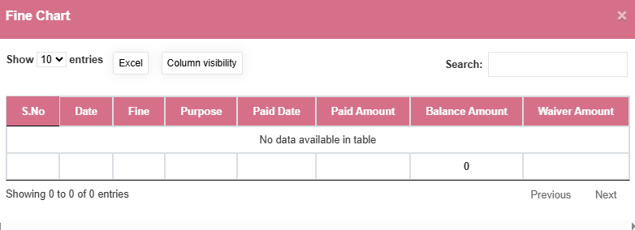

* The **Fine Chart** in the Collection screen facilitates the tracking and management of fines imposed for specific reasons, separate from regular penalties.
* It displays complete details such as **fine date**, **purpose**, **paid date**, **paid amount**, **balance**, and **waivers granted**.
* Fines are assigned for specific non-compliances or violations and are recorded clearly for future reference.

**MODULE NAME – CLOSED**

* The **Closed** screen is used to manage and finalize loans that have been **fully settled**, meaning all dues, penalties, and charges are cleared.
* It allows authorized users to **close loans** once there are **no outstanding balances**, ensuring the loan lifecycle is properly completed.
* Upon closure, all customer and loan data remain accessible for **audit and administrative purposes**, ensuring transparency and traceability.
* After a loan is successfully closed, it can be **moved to the NOC (No Objection Certificate) section**, which handles certificate issuance to the customer.
* A **Closed Remark** modal is included, allowing users to:
* Add remarks or comments during closure
* Update the **sub-status** of the loan to reflect its final state.
* Maintain proper closure history and reasoning for future reference.
* The screen ensures **data integrity** by allowing only eligible loans (with ₹0 balance and cleared charges) to be closed, avoiding accidental closure of active loans.

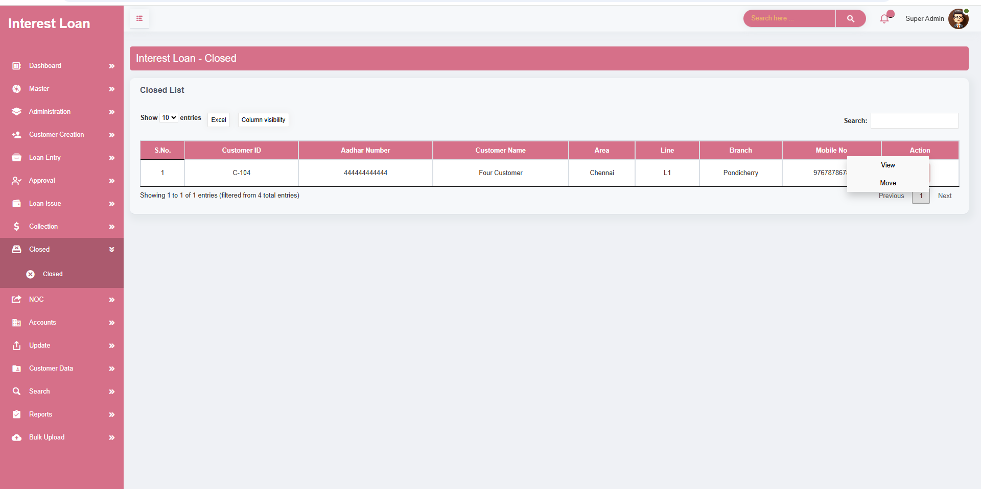

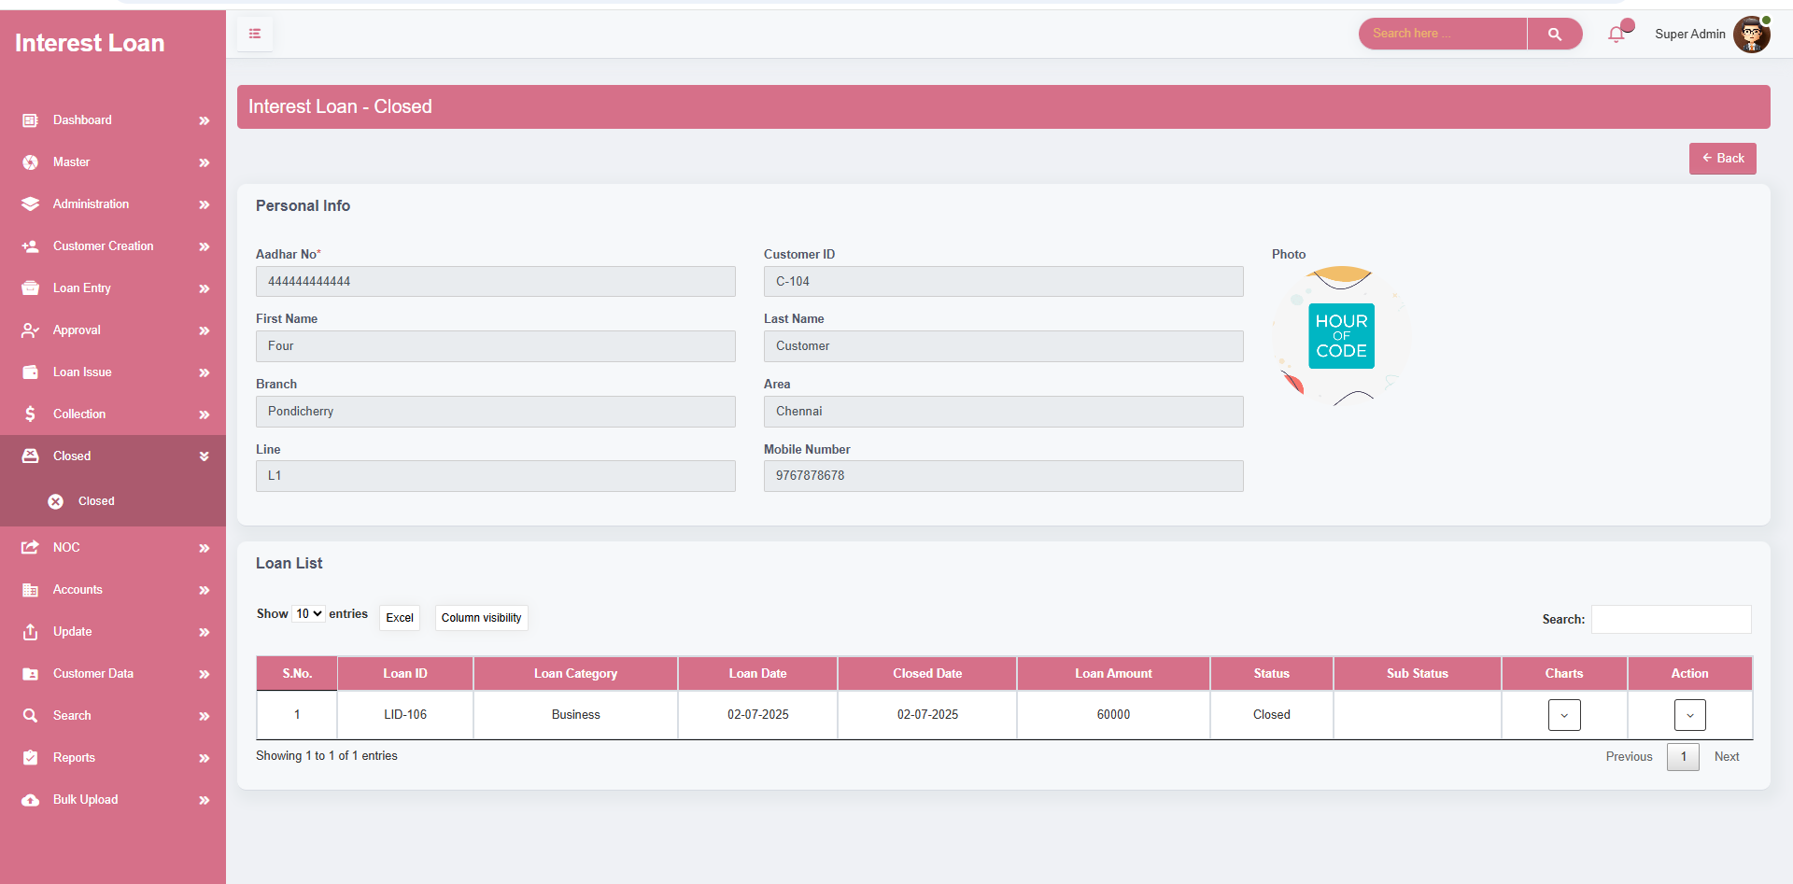

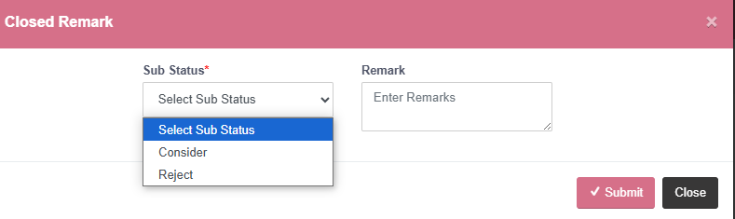



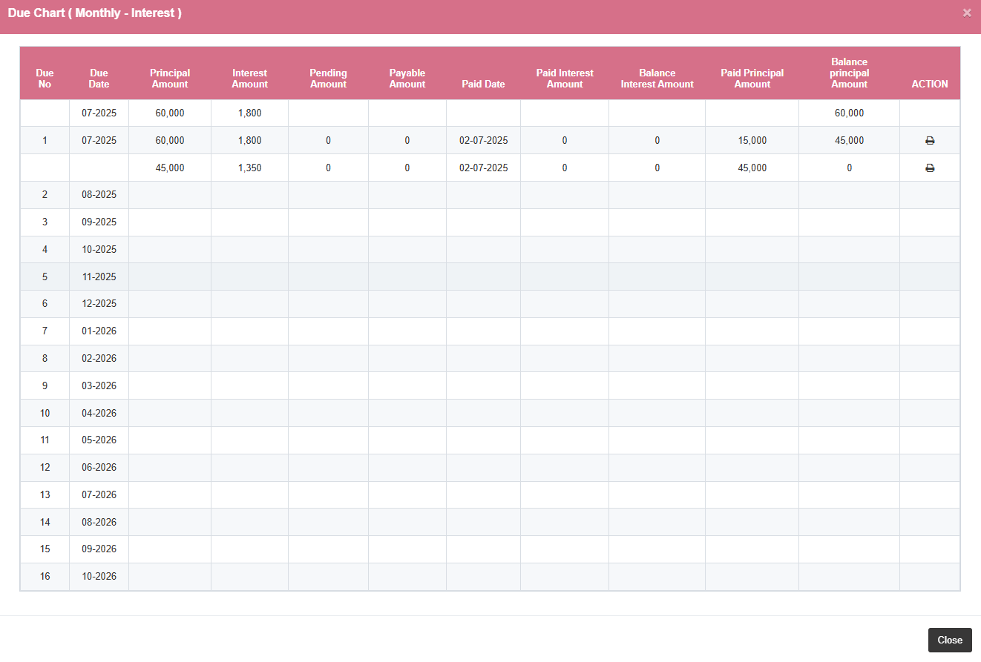

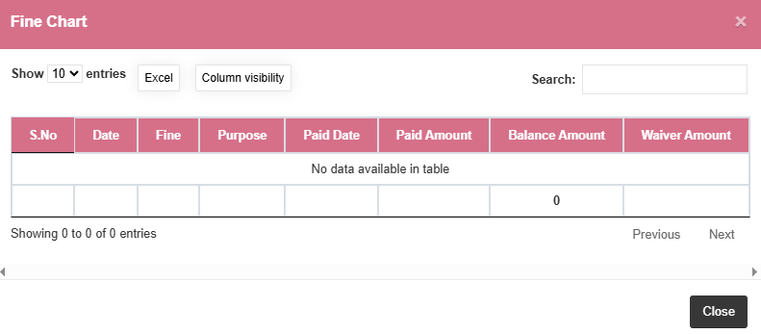

**MODULE NAME – NOC**

* The **NOC screen** is designed to handle the issuance of **No Objection Certificates** for loans that have been fully settled and officially closed.
* It serves as a centralized module to **manage and store NOC-related documents**, ensuring proper tracking and retrieval of certificate records.
* Users can **select specific documents** (such as property papers, cheques, ID proofs, etc.) to be returned to the customer at the time of NOC issuance.
* The screen enforces **verification of all necessary documents and certificate conditions** before allowing the release of the NOC, maintaining legal and procedural integrity.
* A **read-only section displays customer personal details** and closed loan summary for quick reference and cross-verification, ensuring the correct customer and loan record is processed.
* The screen lists all **closed loans linked to the customer**, displaying:
* Loan ID , Loan Category , Loan Date , Loan Amount , Closure Date ,Status & Sub-status , NOC issuance actions
* This feature ensures that the NOC process is **transparent, auditable, and compliant**, providing assurance for both the institution and the customer.
* Two key actions are available for each closed loan:
* **NOC Summary**: Displays a detailed summary of the loan closure, document release details, and NOC issuance information.
* **Remark View**: Shows remarks entered during the loan closure process, including sub-status history and any administrative notes.

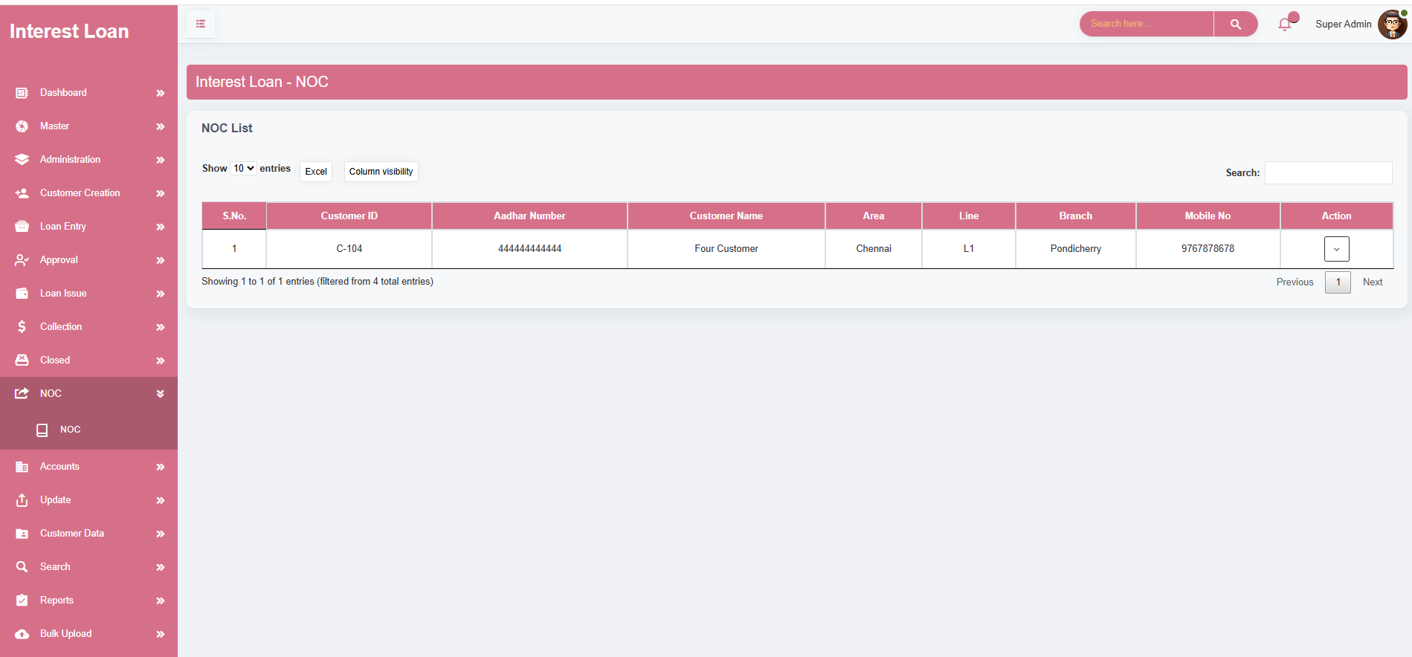

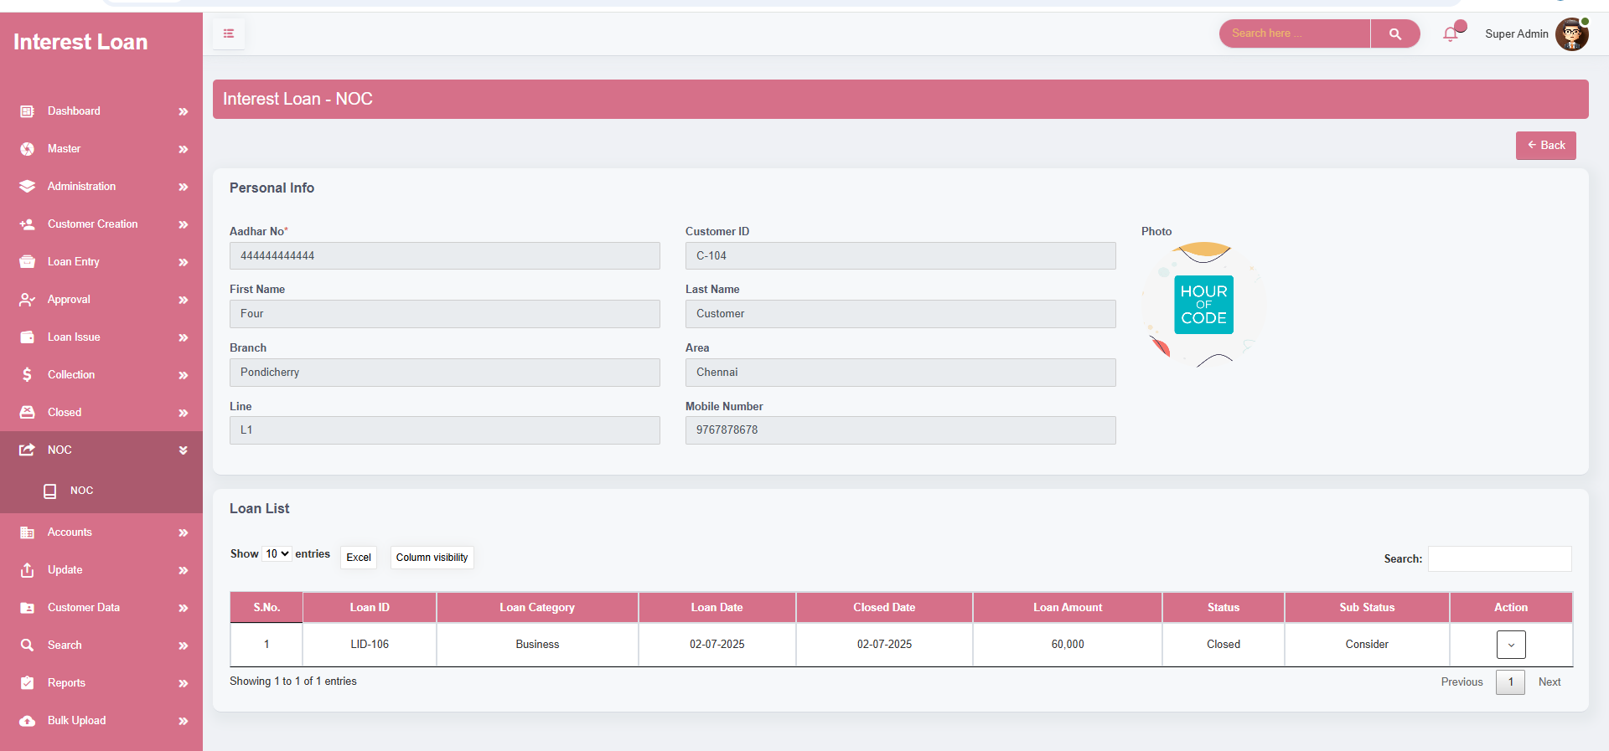

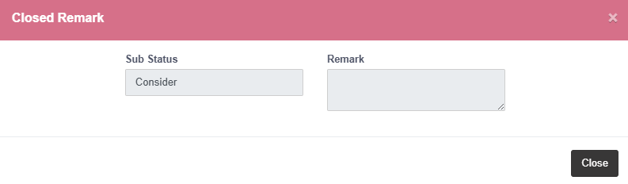

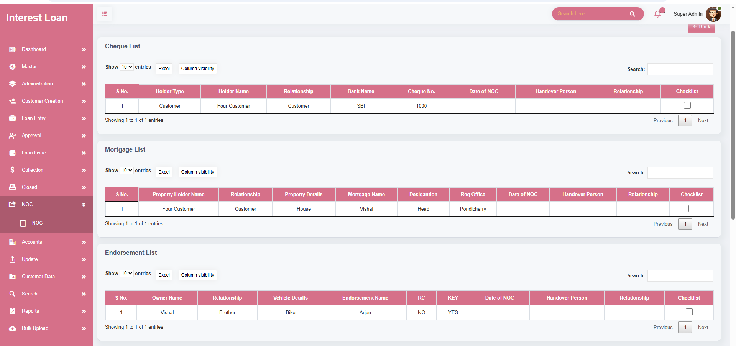

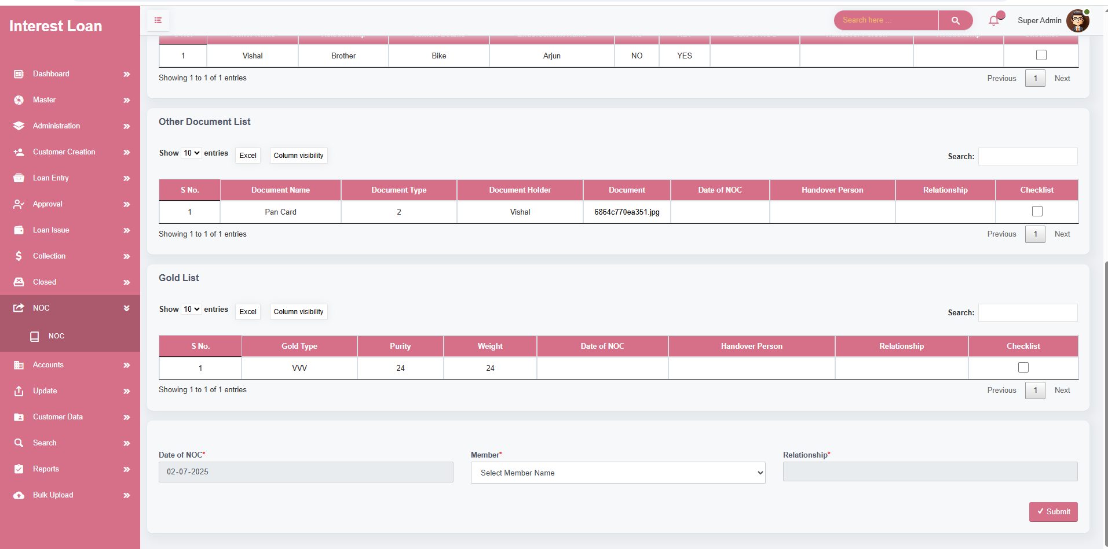

**MODULE NAME – ACCOUNTS**

* Serves as the central hub for tracking and managing **financial transactions**, including collections, loan issues, expenses, and more.
* Provides **real-time monitoring** of all financial movements within the organization.
* Supports **collection entries**, expense tracking, and other incoming/outgoing financial records to ensure transparency.
* Maintains and displays **opening and closing balances** for both hand cash and bank cash, aiding in accurate daily cash flow tracking.
* Helps manage **manual and system-generated entries** with proper verification and audit support.
* Ensures that financial operations are accurately reflected in the system for reliable **reporting, auditing, and compliance**.

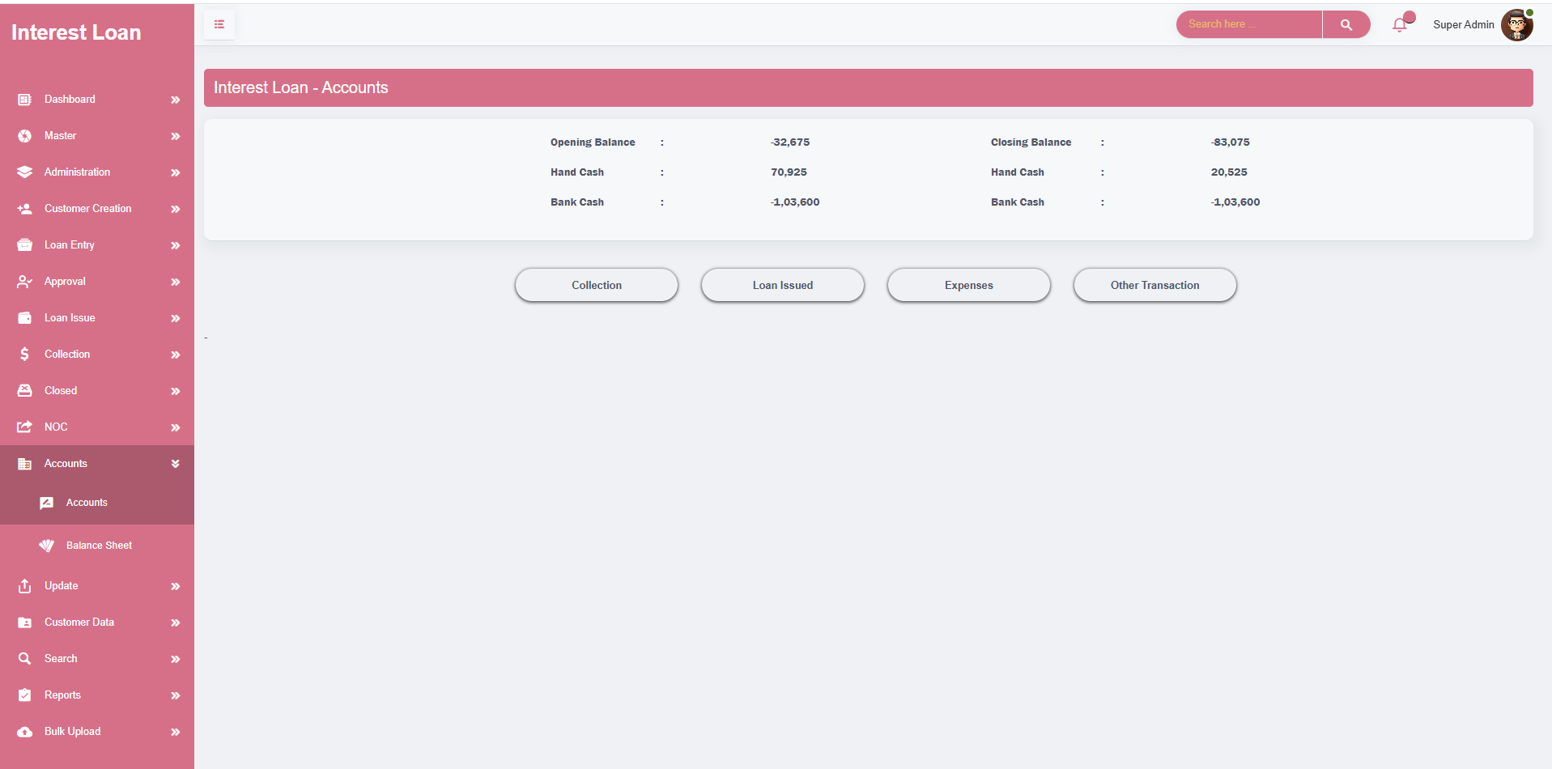

* Displays a **comprehensive list of collections** made by users, including key details such as:
* Branch, Line, User, Number of bills collected, Total collection amount Associated actions (e.g., collect, view).
* Offers a **real-time summary** of daily and historical collections to support transparent and effective **financial tracking**.
* Lists **loan disbursement details**, showing:
* User , Branch and line information , Number of loans issued , Total net cash disbursed ,Remaining balance (in hand)
* Supports **monitoring of loan issues and outstanding balances**, ensuring that disbursement activities align with financial policies and availability.
* Enhances **accountability and oversight** across branches and agents by keeping track of financial inflows (collections) and outflows (loans issued) at a granular level.

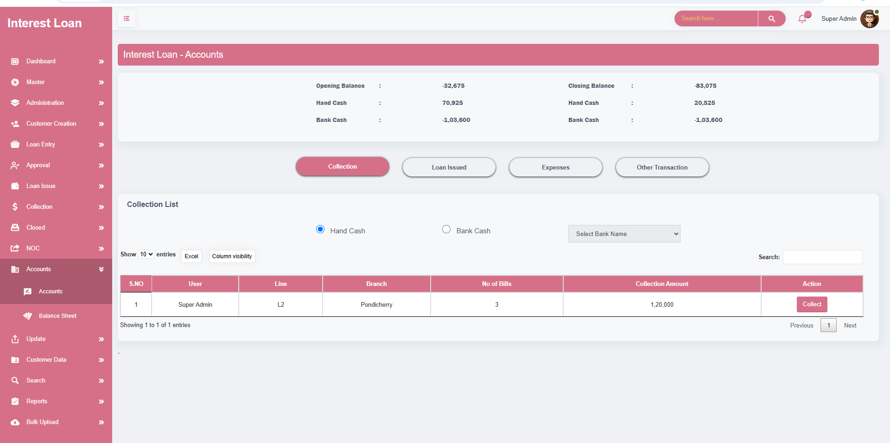

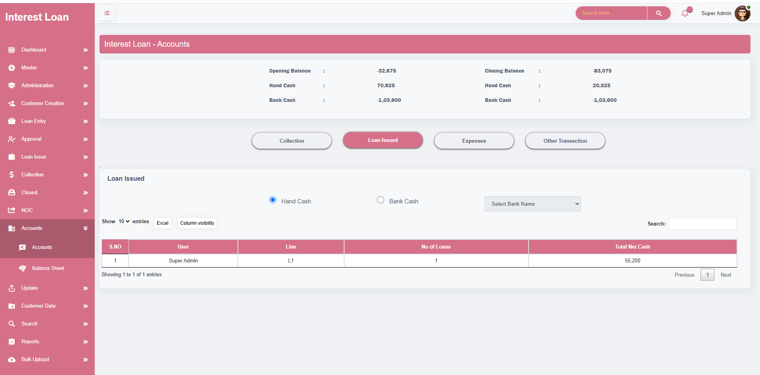

* The **Add Expense modal** is designed to streamline the recording and management of organizational expenses within the Accounts screen of the finance software.
* It offers a **structured and user-friendly interface** for entering complete details about each expense transaction.
* Users can record essential expense data, including:
* Invoice ID, Branch Name, Expense Category, Description of Expense, Expense Amount, Transaction ID
* Supports the **addition and deletion of expenses** to maintain accurate and up-to-date financial records.
* Helps ensure **clear visibility of expenditures** across different branches or departments, enhancing internal accountability.
* Plays a vital role in **financial reporting**, budget planning, and audit preparedness by keeping all expense entries well-documented and easily accessible.

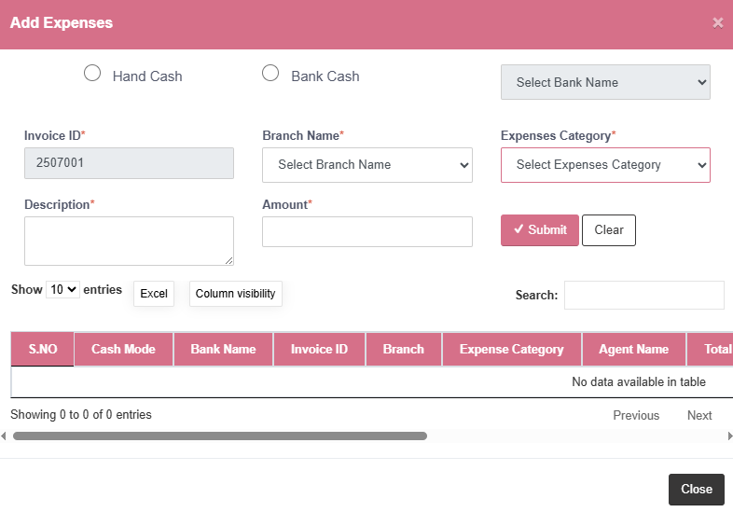

* The system supports **various financial transaction types**, ensuring comprehensive coverage of day-to-day financial operations within the organization.
* Transactions include: **Deposits, Credits, Debits, Investments, Loan Advances**
* A dedicated interface allows users to record these transactions with the following key fields: **Transaction Category , Transaction Type , Bank Name , User Name Amount , Remarks**
* Ensures that **all non-collection and non-loan transactions** are accurately documented and auditable.
* Provides **transparency and accountability** across all types of financial movements within the system.

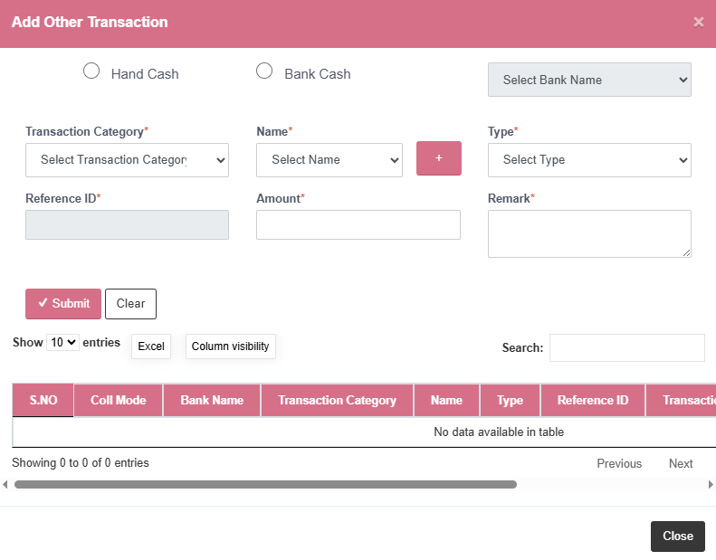

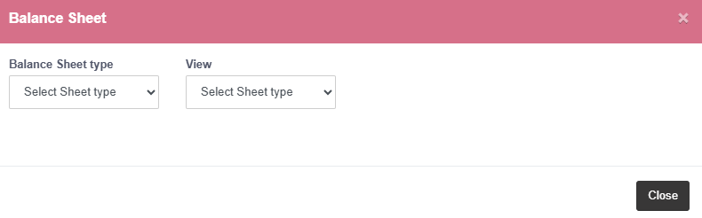

**ACCOUNTS – BALANCE SHEET**

* The **Balance Sheet** screen offers a **comprehensive snapshot** of the organization's financial position at a **specific point in time**.
* It aggregates and presents **all key financial metrics** to evaluate performance and profitability.
* Breaks down **net financial benefit** over the selected period by summarizing:
* **Interest Income**, **Document Charges**, **Processing Charges**, **Penalties Collected**, **Fines**, **Other Incomes** (such as miscellaneous service charges or adjustments)
* Helps in identifying: **Overall financial gain or loss, Income sources and their contribution** , **Cash flow trends**
* Assists management in **financial planning**, **auditing**, and **compliance**.
* Ensures **real-time visibility** into profits, losses, and resource allocations within the organization.

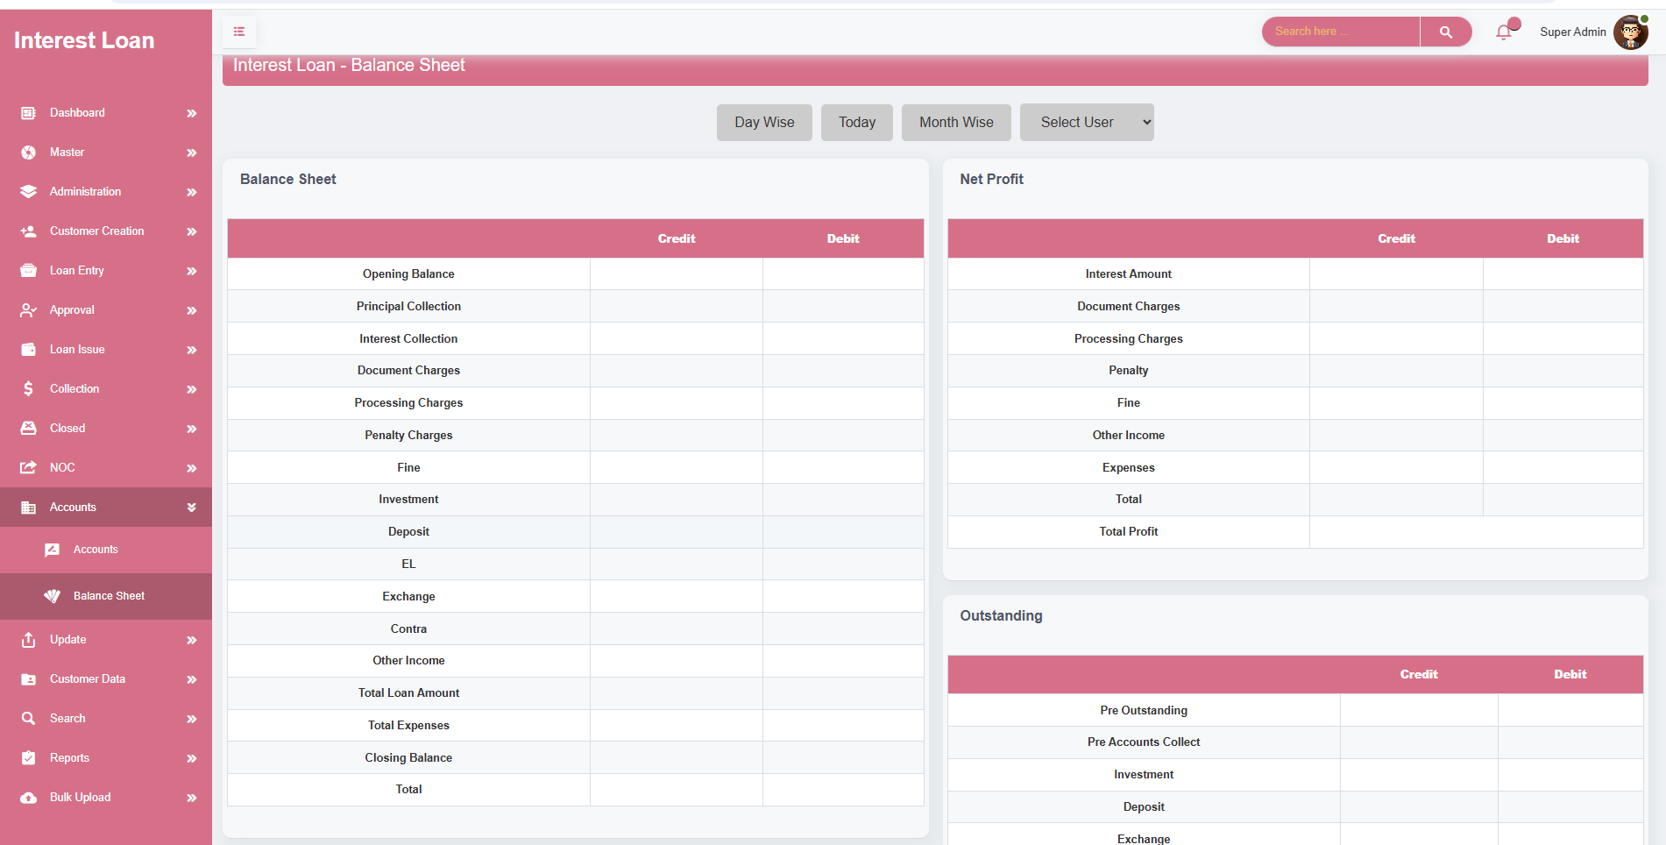

**UPDATE – UPDATE CUSTOMER**

CUSTOMER PROFILE

* The **Customer Update** screen provides a **centralized and structured interface** to review and modify the information of existing customers.
* This screen is **exclusively accessible** for customers who have **already taken a loan** through the company, ensuring that only verified profiles are editable.
* It allows users to update critical sections of customer data, including:
* **Personal Information, Family Information, Guarantor Details, Address Information, Bank Details, KYC Documents, Occupation and Property Details**
* Ensures that customer records are **accurate, complete, and up-to-date** for ongoing loan servicing, audits, or future loan eligibility.
* Helps maintain a **central source of truth** for customer information, improving operational efficiency and compliance.
* Designed with an intuitive layout to make **data modification easy and secure**.
* Supports internal audit, verification, and record-keeping by keeping a **trackable log of updates**.

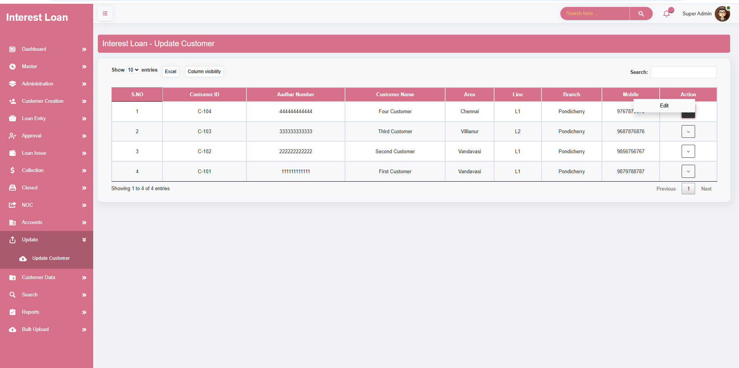

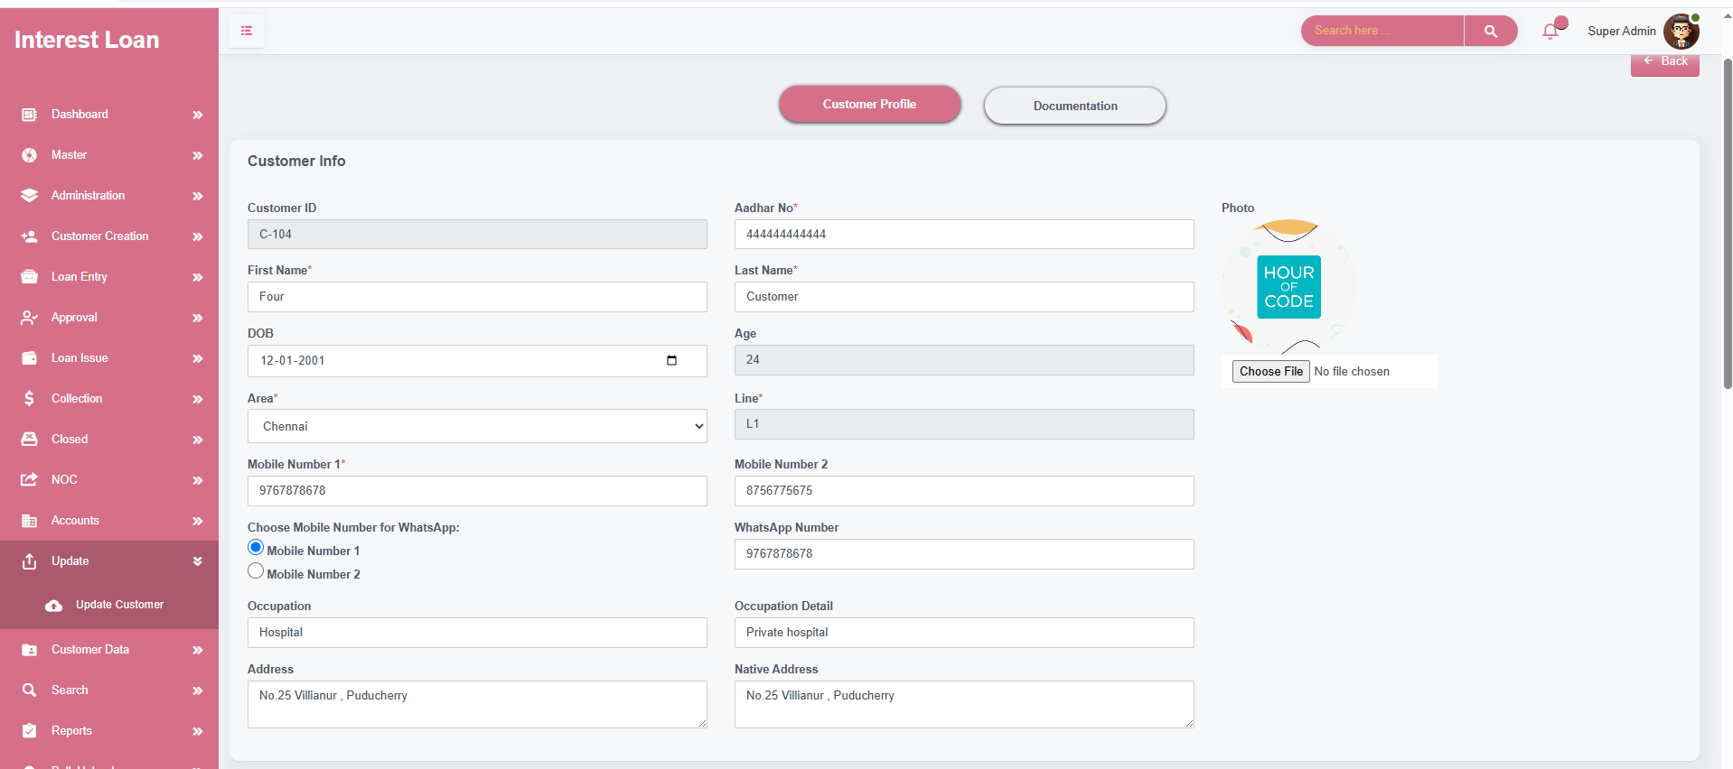

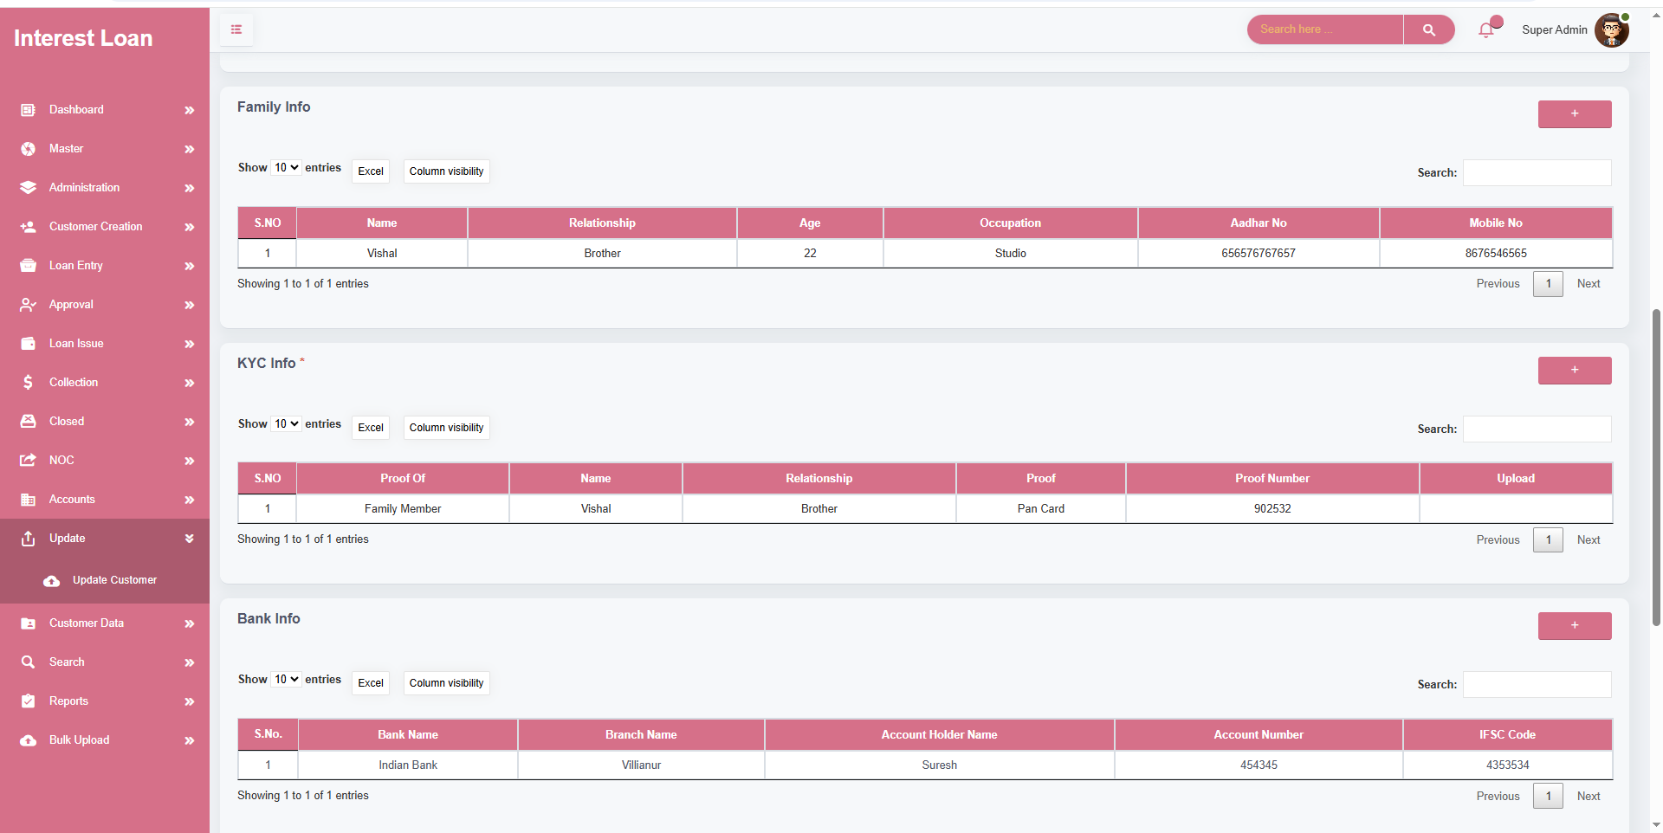

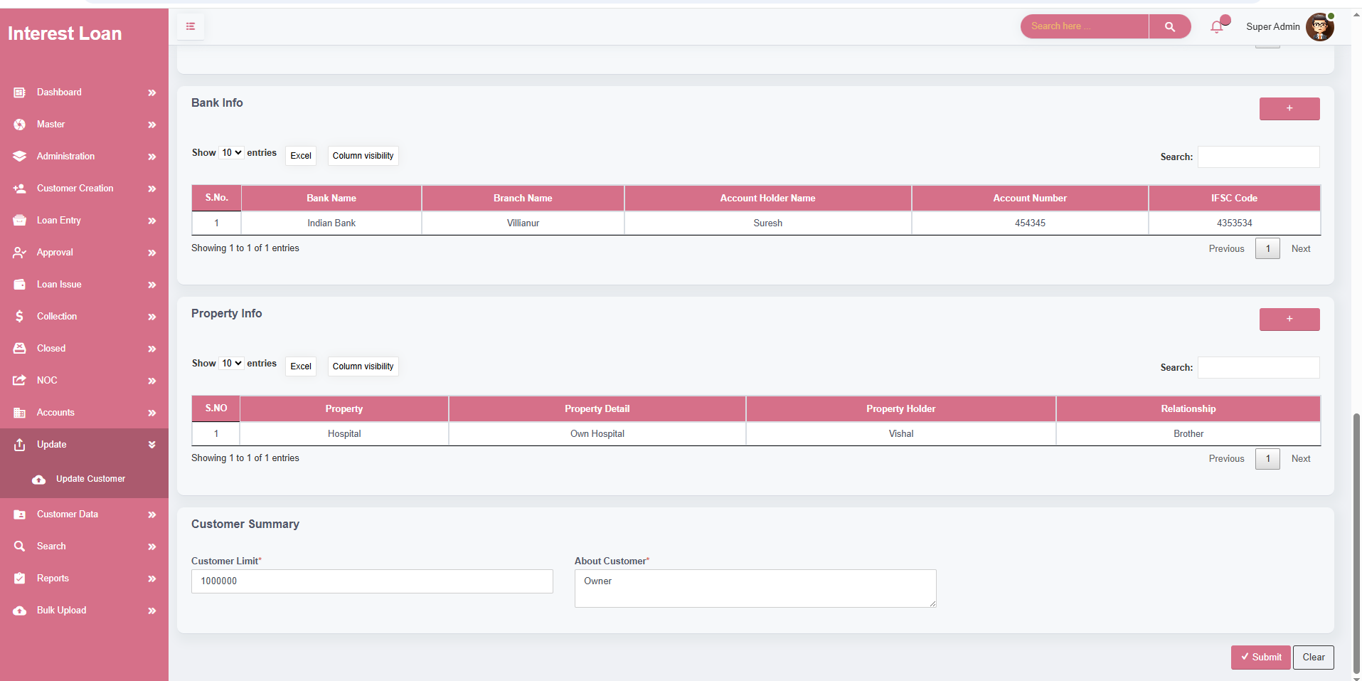

DOCUMENTATAION

* The **Document Update** screen is used for **managing and updating all loan-related documents** for a customer in a structured and organized manner.
* It ensures that **all critical documents** associated with the loan are properly **uploaded, stored, and maintained** for auditing, legal, and operational purposes.
* Users can manage and update the following key document categories:
* **Loan Information** – Associated loan details.
* **Cheque Details** – Includes cheque count, holder information, bank name, and uploads.
* **General Document Information** – Includes document name, type, holder info, and uploads.
* **Mortgage Information** – Includes property, relationship, registry, and mortgage value details with upload support.
* **Endorsement Information** – Includes vehicle details, keys, RC info, and document uploads.
* **Gold Information** – Includes gold type, purity, weight, and valuation data.
* **All upload fields are mandatory**, ensuring that no document-related section is left incomplete during the update process.
* This module ensures:
* **Centralized document management** for each loan.
* **Compliance** with documentation requirements.
* **Audit readiness** by keeping all documentation updated and accessible.
* Helps maintain **transparency and completeness** of records for both internal use and customer servicing.

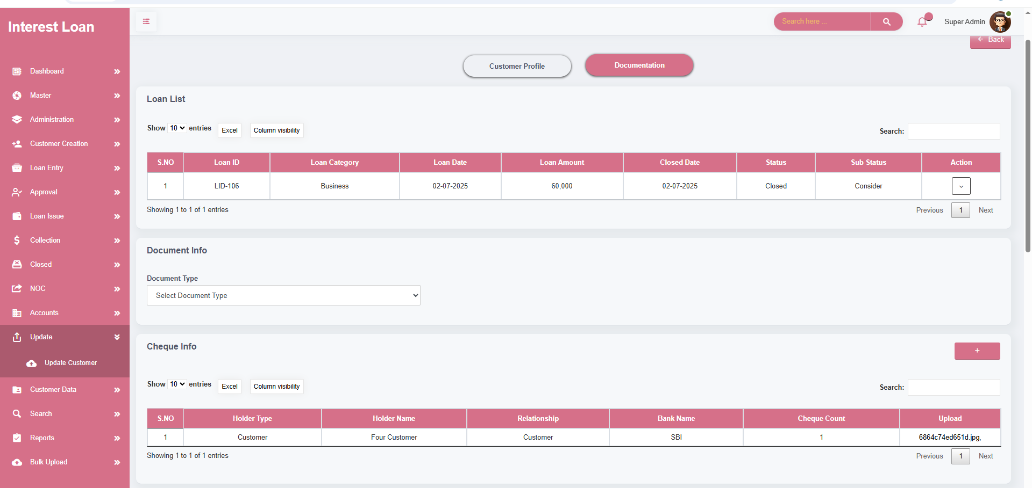

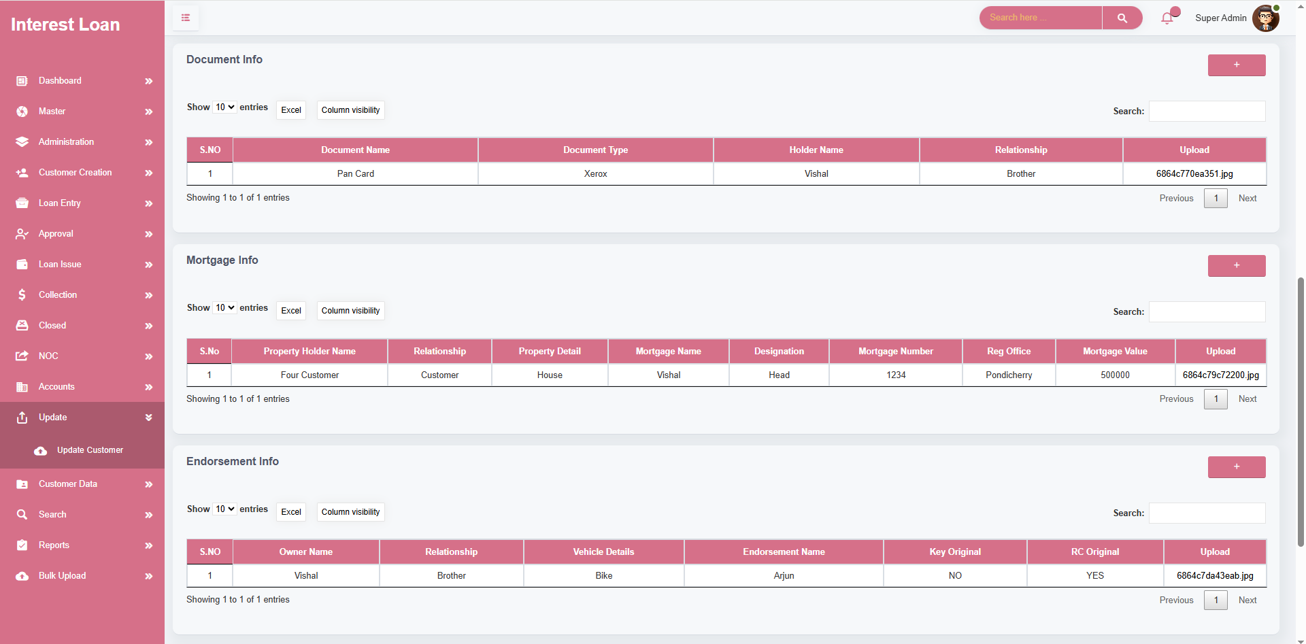

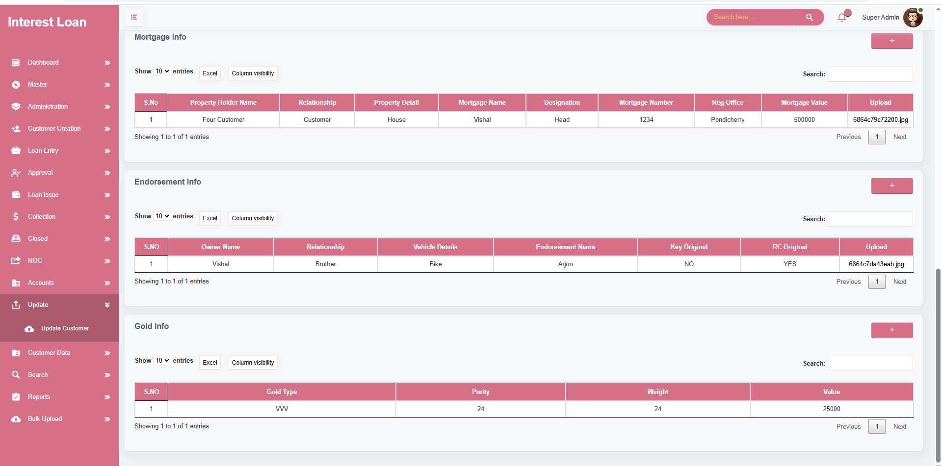

**MODULE NAME – CUSTOMER DATA**

* The **Customer Data** screen is designed to manage both **new promotions** and **existing customer profiles**, streamlining customer relationship and lifecycle management.

New Promotion List

* Displays all **newly promoted customer entries** for easy monitoring and follow-up.
* Enables administrators to **add or remove promotions** as needed.
* Automatically checks if the **entered mobile number already exists** in the system and alerts the user with the **current status** of the customer to prevent duplication.

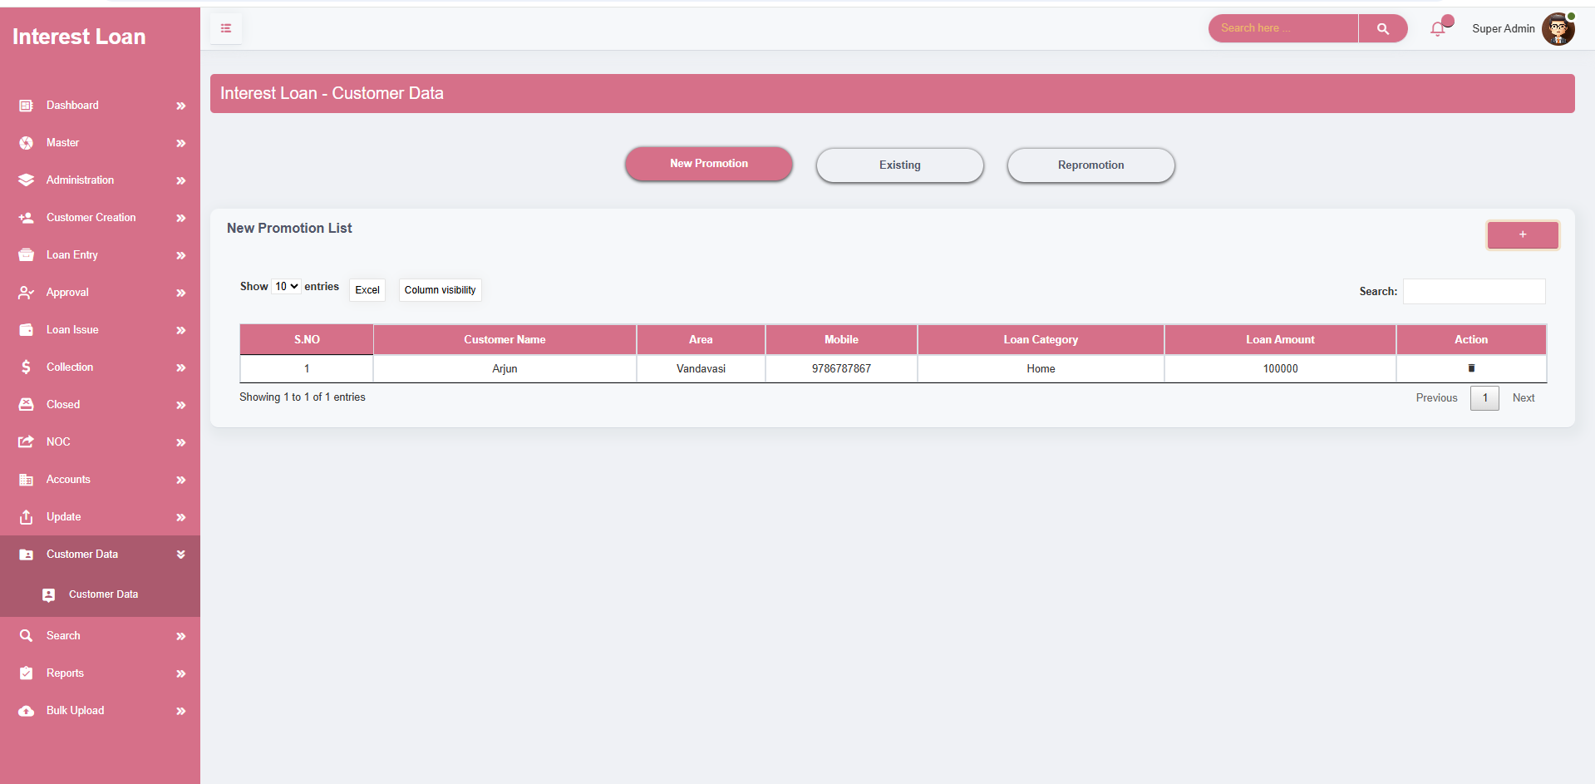

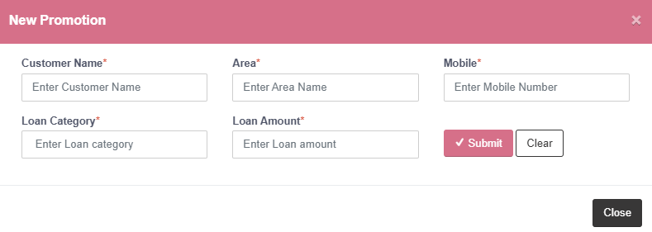

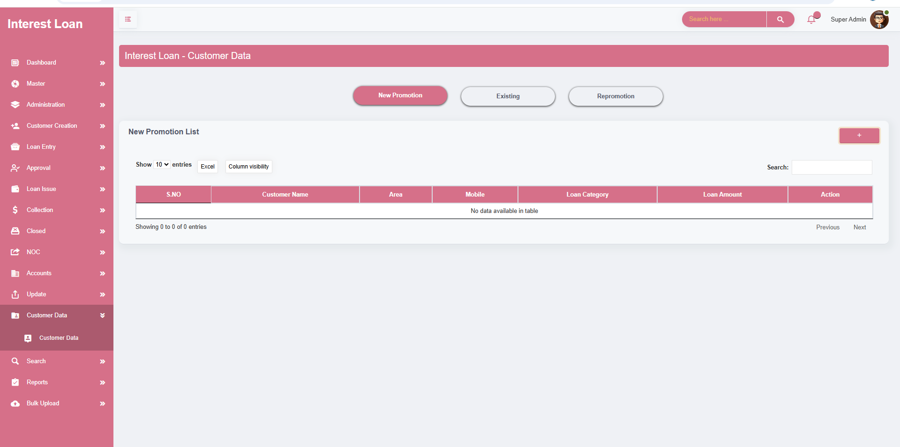

EXISTING List

* Shows detailed information about **customers who have closed their loans**.
* Includes **status** and **sub-status** to provide clear insight into the customer’s closure stage.
* Offers **three follow-up options** for administrative tracking:
* **Need** , **Later** , **To Follow**

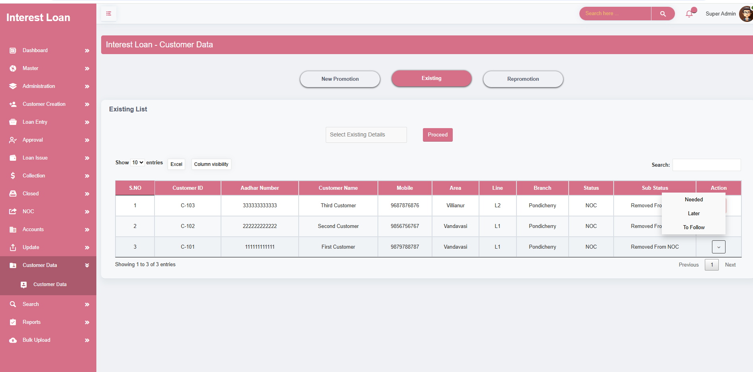

Repromotion

* Displays data of **customers whose loans were canceled or revoked**.
* Lists **status** and **sub-status** to track repromotion eligibility and stage.
* Provides **three tracking actions** for these customers:
* **Need** , **Later** ,**To Follow**

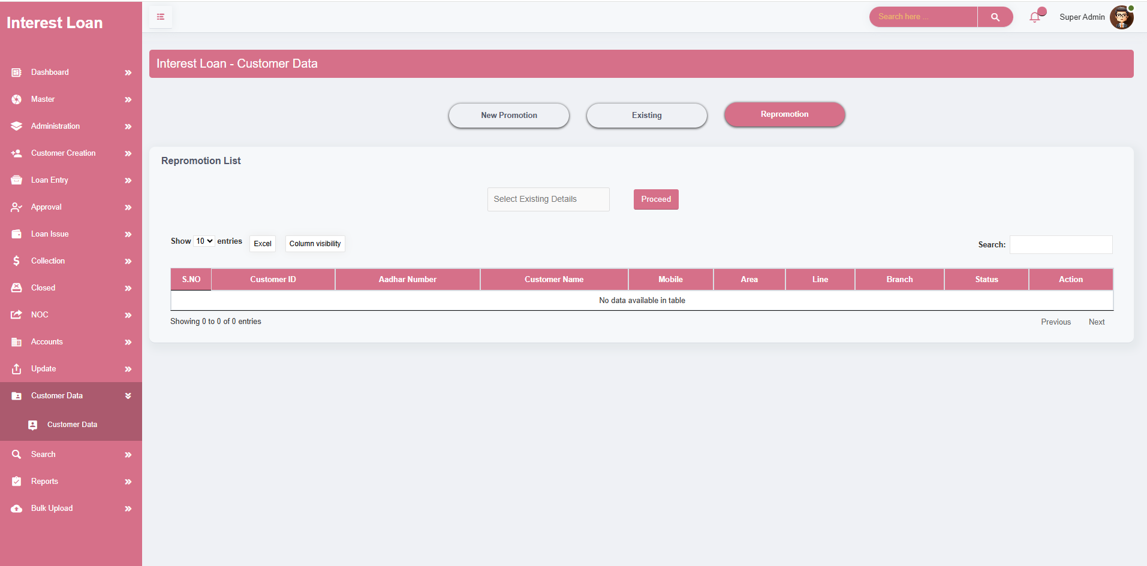

**MODULE NAME – SEARCH**

* The **Search screen** is a critical module for quickly accessing and managing **customer and loan data** within the finance software.
* Allows users to **retrieve customer profiles** using multiple search parameters:
* **Customer ID**, **Customer Name**, Area, **Mobile Number**
* Enter one or more of the above parameters and click **"Search"** to fetch relevant customer records.
* Customer List – data to be showed
* Displays a **summary table** of search results, including essential customer details that match the entered criteria.
* Enables users to **easily navigate through customer records** for operational and support tasks.
* View & Customer Status
* Click on the **"View"** action in the results table to access the **Customer Status** section.
* This section provides a **detailed breakdown** of the selected customer’s loan-related data, including: Loan Profiles, Due Charts, and Interest & Principal Calculations, Penalties, Approval History, Documentation Details, NOC Summary
* Offers a **complete 360° view** of customer engagement and financial history for analysis and decision-making.

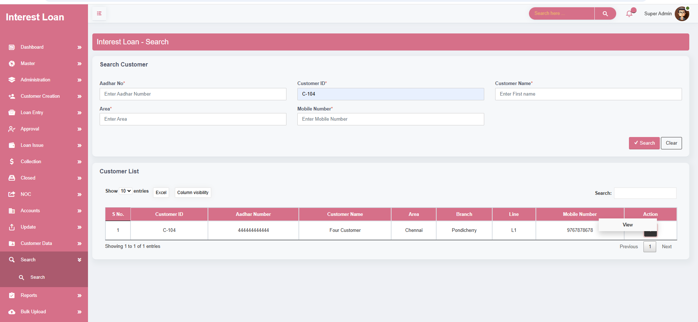

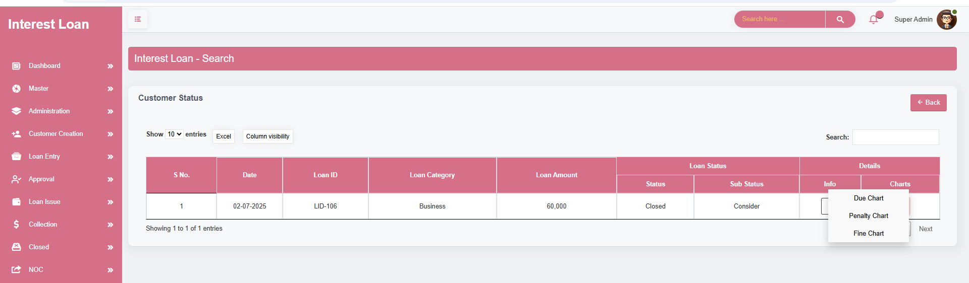

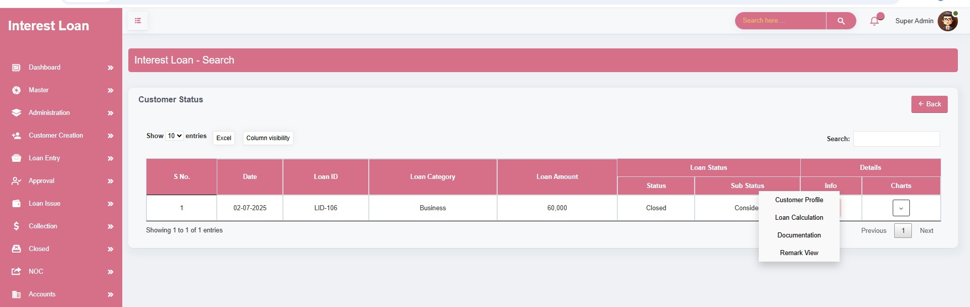

**REPORTS – LOAN ISSUE REPORT**

* The **Loan Issue Report** screen is a powerful reporting tool designed to **track and analyze all loans issued** by the organization within a selected time frame.
* Filter by Date – Use the **From Date** and **To Date** fields to define a specific **date range** for the report.
* Once the date range is entered, the system generates a **list of all loans disbursed** during that period.
* Report Table Overview
* Displays a **comprehensive table** of all loan entries issued within the selected date range.
* Each entry in the report includes **key details**, such as:
* **Customer Information** (Name, ID, Aadhar) **, Loan ID and Category, Loan Amount, Document Charges & Processing Fees, Net Cash Disbursed, Agent or Guarantor, Details Disbursement Method (Cash, Bank Transfer, etc.)**

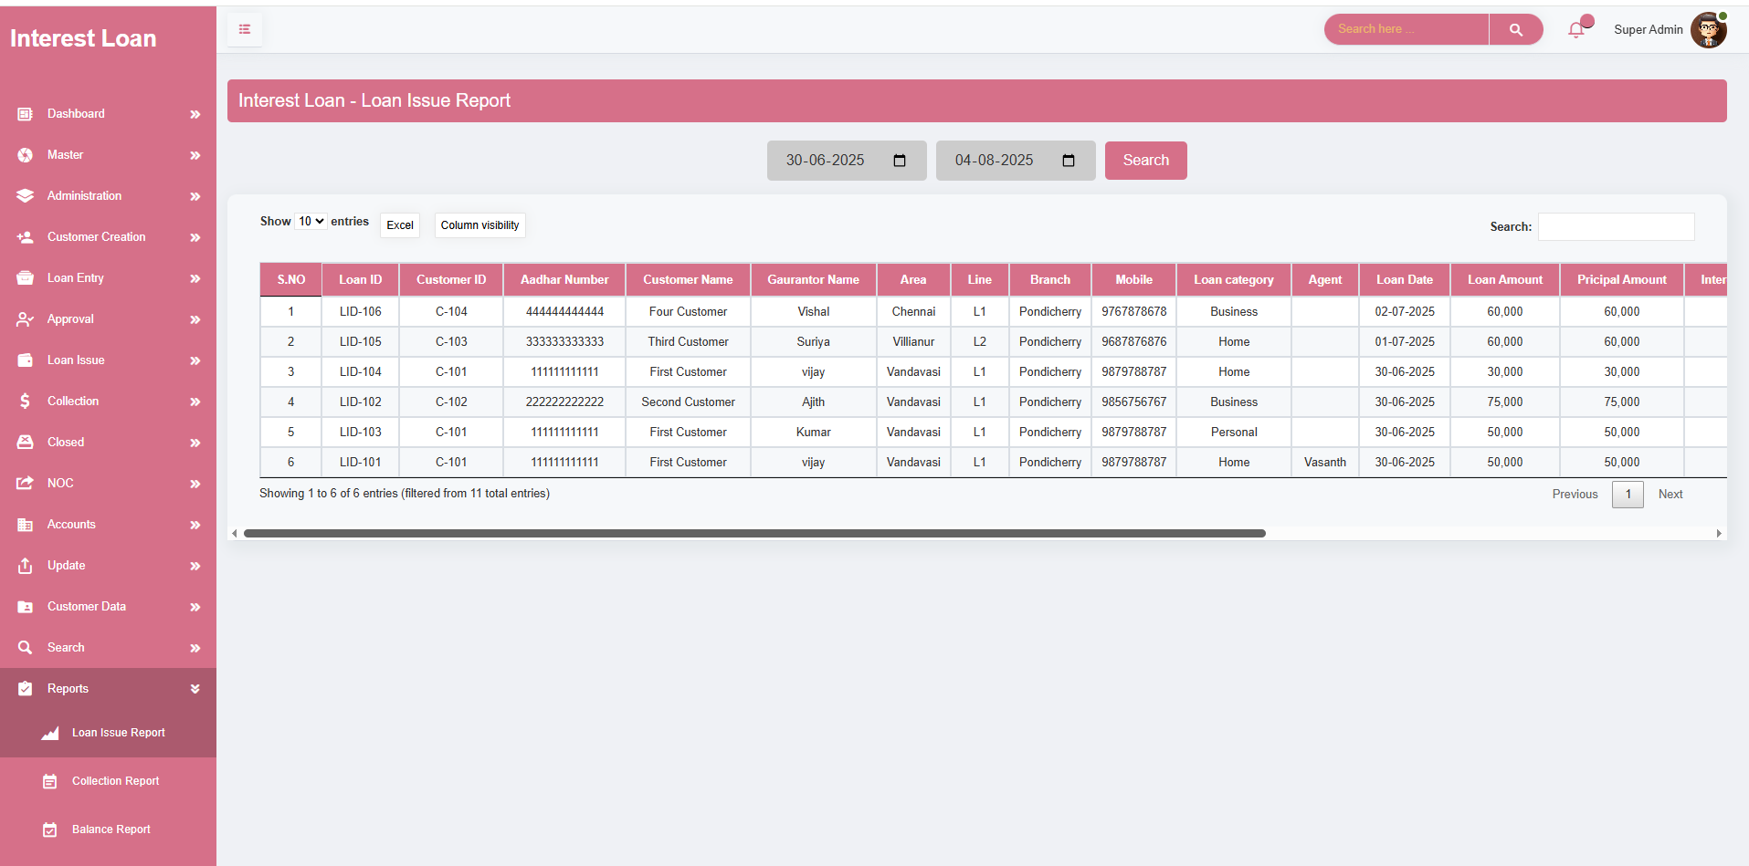

**REPORTS – COLLECTION REPORT**

* The **Collection Report** screen offers a detailed and structured view of all **loan repayment transactions** made within a selected period. It is an essential tool for **administrators, finance managers, and auditors** to monitor and analyze the organization's cash inflows from loan collections.
* Filter by Date – Use **from Date** and **To Date** fields to define the desired **reporting period**.
* Once applied, the system generates a **complete list of all collection entries** made during that time frame.
* Report Table Includes: Each entry in the **Collection Report** table contains:
* **Customer Information** (Customer Name, ID, Aadhar No.), Loan ID and Category, Collection Date, **Collection ID and Mode** (Cash, Bank Transfer, etc.), **Paid Amount** (Interest, Principal, Penalty, Fine), Pending and Payable Amounts, **Total Waivers** (Interest, Penalty, Fine, Principal), User or Agent Involved.

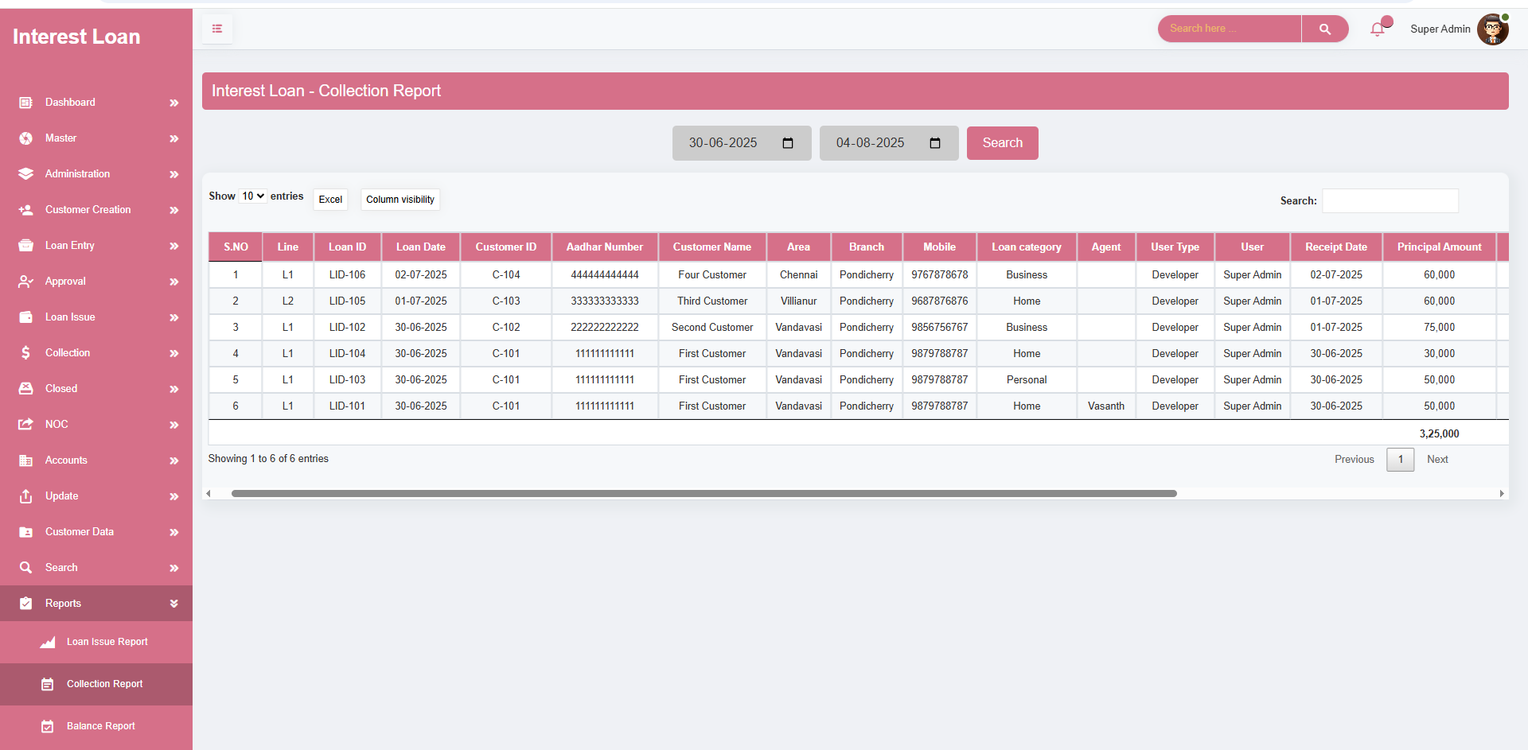

**REPORTS – BALANCE REPORT**

* The **Balance Report** screen is a key feature within the finance software, designed to give administrators and finance teams a **clear and detailed overview of loan balances, pending dues, and payment progress** within a selected period.
* Date – Based Report Generation
* Use **Date** fields to filter the report by a specific time frame
* The system generates a comprehensive list of **loans with outstanding or cleared balances** during that period.
* Report Table Includes: Each entry in the **Balance Report** table includes:
* **Customer and Loan Information** (Customer ID, Loan ID, Category), Loan Amount and Disbursed Date, Outstanding Principal and Interest, Due Dates and Payment Status, Overdue or Pending Amounts, Last Paid Date and Balance Remaining

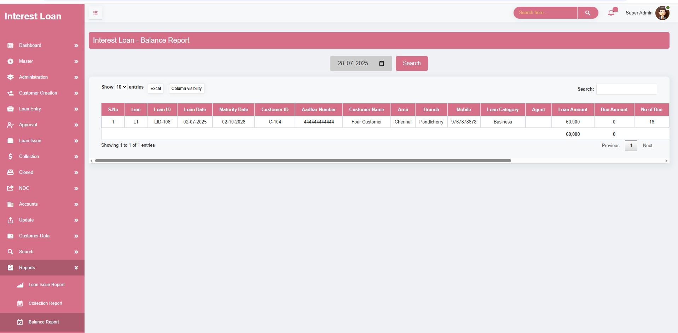

**REPORTS – BALANCE REPORT**

* The **Closed Report** screen in the finance software provides a centralized view for accessing and reviewing all **loans that have been successfully closed** within a specified time frame. This module ensures that all closed loans are tracked and documented for administrative and auditing purposes.
* Date- Based Report Generation
* Select **from Date** and **To Date** to filter and view closed loans within the selected date range.
* Report Table Includes: Each row in the **Closed Report** table contains:
* **Customer Details** (Customer ID, Name, Branch), Loan ID and Category, Loan Amount and Disbursal Date, Closure Date, Closed Status and Sub-status, Remarks or Closure Notes.

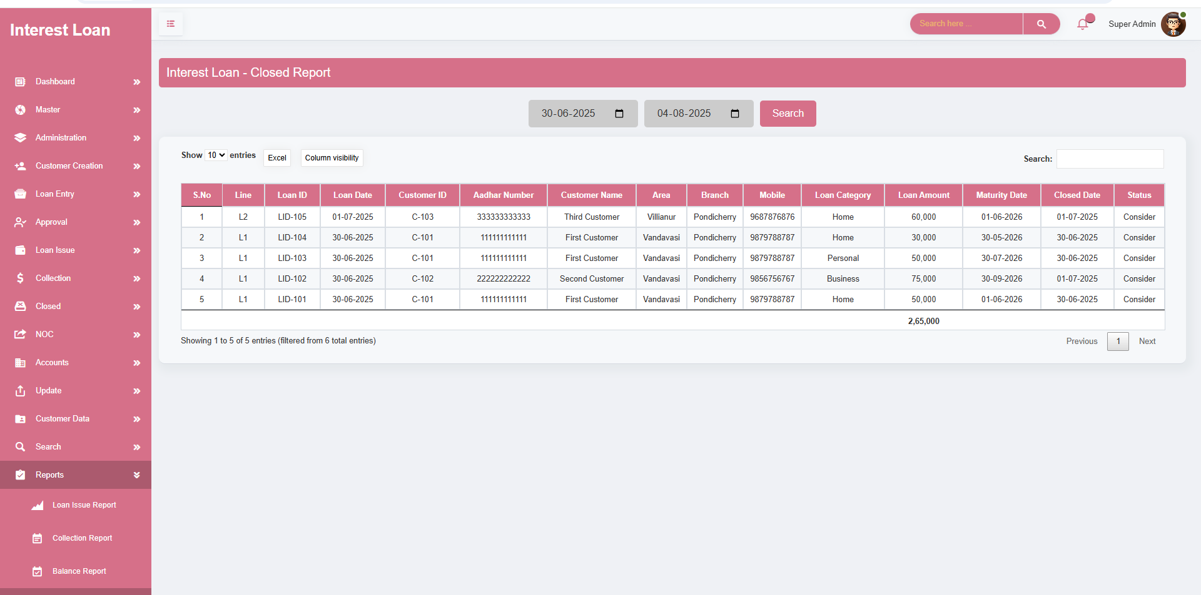

**REPORTS – LEDGER VIEW REPORT**

* This report shows the **monthly breakdown of principal and interest repayments** for each loan per customer over a 12-month period. It tracks the payments made and displays the data accordingly.
* The table displays **monthly principal and interest** due for each loan.
* If the **customer pays dues for 12 months**, the system reflects:
* The **previous month**'s values (as a history).
* The **current month** (where the payment was made), showing the **paid principal and interest**
* Date- Based & Loan Category to filter and view closed loans within the selected date range.

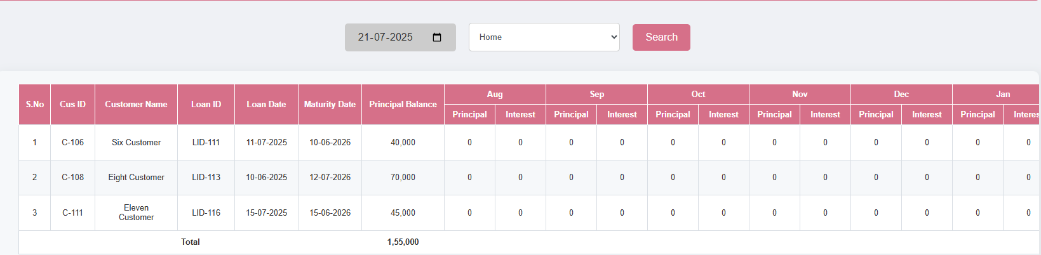

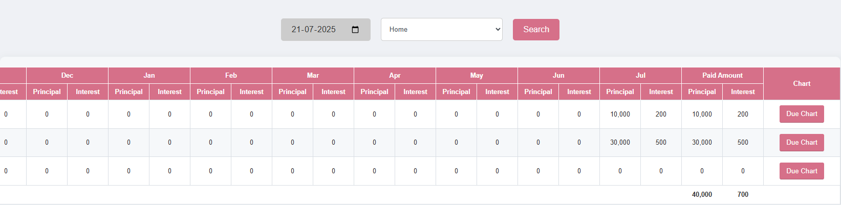

**MODULE NAME – BULK UPLOAD**

* The **Bulk Upload** screen is designed to streamline the addition of multiple customers into the finance system efficiently. It simplifies the process of onboarding customers by allowing data to be uploaded in bulk through an Excel file.
* **Mass Customer Onboarding:** Upload multiple customer records at once using a predefined Excel format.
* **Skip Manual Steps:** Eliminates the need to go through individual processes like Loan Entry, Approval, and Loan Issue for each customer
* **Seamless Integration:** Once uploaded, the customers are directly added into the **collection process**, enabling faster deployment and inclusion in the loan lifecycle.
* **Error Checking:** Validates data during upload to ensure accuracy and completeness before integration.
* **Operational Efficiency:** Ideal for initializing large batches of loans or migrating data from another source.
* The system automatically maps columns from the uploaded Excel file to the required database fields, reducing manual configuration and minimizing errors
* In case of upload failures or invalid entries, the system provides detailed error messages and allows re-uploading corrected data without duplicating valid records.
* File format must be **.xls** or **.xlsx**.
* Mandatory fields in the Excel file typically include
* System validates data and provides a **summary of successful and failed uploads**.

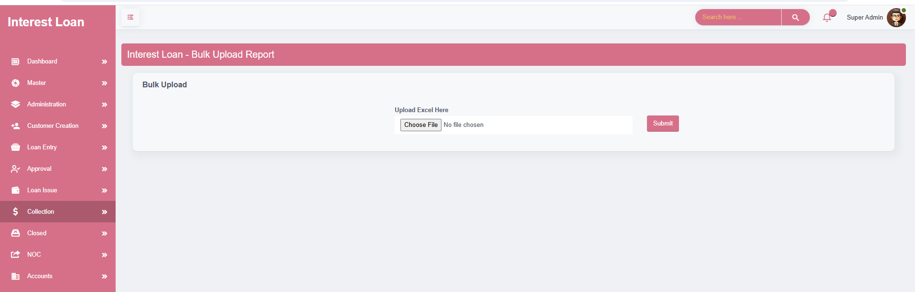

BULK UPLOAD EXCEL FORMAT

